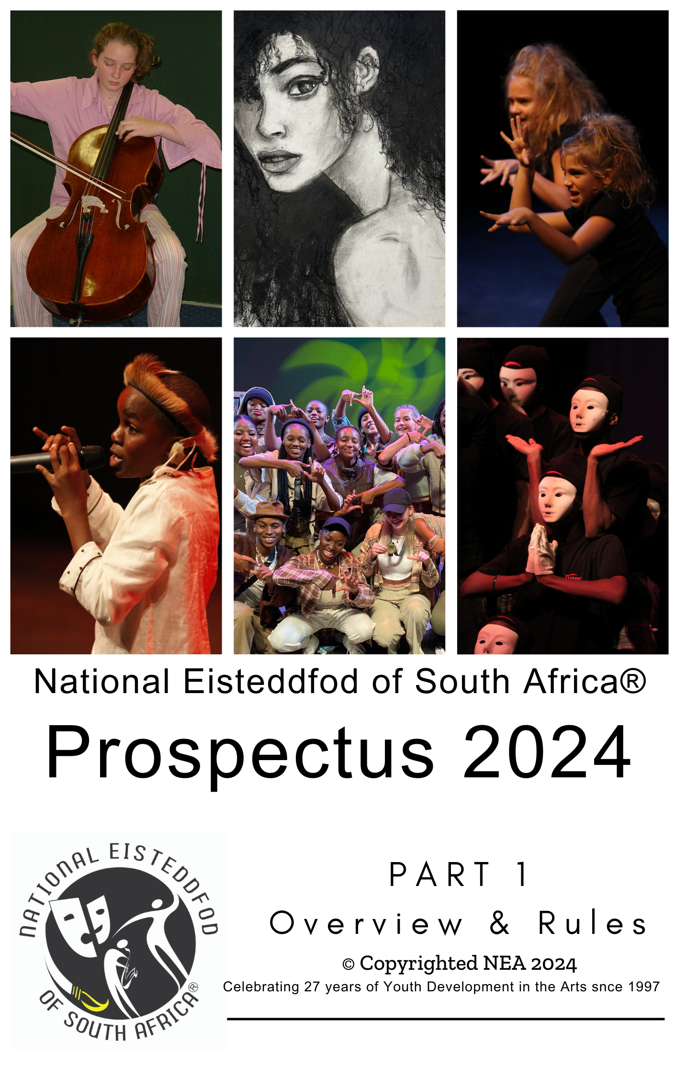


NATIONAL EISTEDDFOD OF SOUTH AFRICA®
Part 1
Overview, Fees & Rules

Extract from

PROSPECTUS
2024 -2026
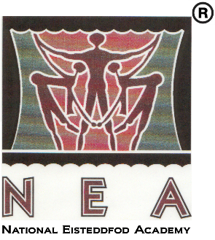

© Copyrighted NEA 2024

(This document may only be copied or reproduced in any way what so ever for the purpose of participating in the activities of the National Eisteddfod of South Africa®.)
Celebrating 29 years of Youth Development in the Arts 1997 - 2026

Contents
Contents i
PART 1 0
Overview 0
MESSAGE FROM THE CHAIRPERSON OF THE BOARD OF DIRECTORS 1
MISSION STATEMENT 2
GOVERNANCE STRUCTURE 2
NATIONAL EISTEDDFOD ACADEMY: AN OVERVIEW 3
Governance structure & staff 6
Programmes and projects 7
Present and Past Sponsors and Partners 9
Previous Partnerships 10
ADJUDICATORS’ FORUM 11
PROGRAM OF EVENTS FOR 2024 12
NATIONAL EISTEDDFOD OF SOUTH AFRICA®: REGIONAL ACTIVITY DATES FOR 2024 12
NEA YOUNG PERFORMER & YOUNG ARTIST AWARDS COMPETITIONS 2024 12
CLOSING DATE FOR EISTEDDFOD ENTRIES IN 2024 12
REQUIREMENTS FOR PARTICIPATION IN EISTEDDFOD 2024: 13
OTHER FEES AND CHARGES FOR 2023 14
CONTACT AND BANKING DETAILS 14
RULES AND REGULATIONS 15
ASPECTS TO CONSIDER WITH ENTRIES 15
GUIDELINES AND REQUIREMENTS FOR VIDEO RECORDED ENTRIES 20
Submission of video recorded entries 20
Guidelines for recording the performance 21
SETTING THE “SCENE” 21
Recording your performance: 22
How to submit the video recording on DVD or flash disk 22
Delivery / postal address: 23
How to send your video to YouTube from your computer 23
STEP 1: Create a YouTube account 23
STEP 2: Creating a YouTube Channel 25
STEP 3: Upload your video to your YouTube Channel 27
STEP 4: Submit your video link 31
Create YouTube channel-Android 34
Upload videos to your Android 35
Create YouTube channel on iPhone 34
Upload videos to your iPhone 35
ACKNOWLEDGEMENT OF ACHIEVEMENT 37
CERTIFICATES & DIPLOMAS 37
ADDITIONAL REGIONAL AWARDS 39
NEA YOUNG PERFORMER AWARDS COMPETITION 41
GUIDELINES FOR THE EVALUATION OF EISTEDDFOD AWARDS 42
GUIDELINES FOR ADJUDICATION: A RUBRIC EXAMPLE 44
NATIONAL EISTEDDFOD YOUNG PERFORMER AWARDS COMPETITION 46
PREVIOUS WINNERS 46
HOW TO ENTER THE NATIONAL EISTEDDFOD OF SOUTH AFRICA® 62
Online Registration 62

PART 1:

Overview

© Copyrighted NEA 2024
(This document may only be copied or reproduced in any way what so ever for the purpose of participating in the activities of the National Eisteddfod of South Africa®.)

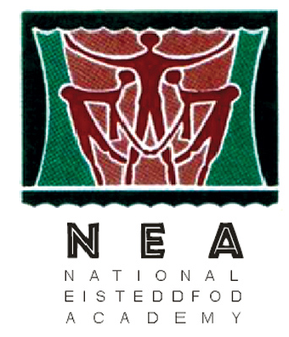MESSAGE FROM THE CHAIRPERSON OF THE BOARD OF DIRECTORS

The National Eisteddfod Academy (NPC), a registered Non Profit Company established in 1997, was created in the sincere belief that access to and participation in the arts are basic human rights, rooted in freedom of expression and creative thought.

The arts, therefore, have a vital role to play in nation building and the well-being of our people. This is echoed in the words of our late national patron Mama Albertina Sisulu when she said: “My great desire throughout my life has been for a better life for the children of this country, this continent and indeed the whole world.”

The National Eisteddfod Academy subsequently established the annual National Eisteddfod of South Africa® as an arts development platform, offering various opportunities to young (and young at heart!) performers in all communities for participation, development and showcasing of talents in music, dance, theatre and fine arts.

Some people might still argue that sporting events are of equal importance as enabler of human development. However, it stands to reason, that none of the attributes of sport has a stronger impact on the personal growth of individual participants, than those of the arts. The essence of arts requires of the participant to expose his sole to people. Exposing and giving of himself, results in a vulnerability that the performer has to overcome and control to establish confidence and belief in himself. In the eisteddfod context, it provides him with affirmation of his value as human being and fulfils the basic need for respect and recognition. In essence, this is the magic of the arts.

It is the sincere believe of the NEA that the National Eisteddfod of South Africa® will continue to make a difference in the lives of many more people, young and old, building trust and understanding between communities and in elevating the status of achievements in the arts.

We wish every participant and supporter many magical moments in their involvement in the arts during 2022-2023.

WSJ VAN WYK
CHAIRMAN

01 MARCH

NATIONAL EISTEDDFOD ACADEMY

MISSION STATEMENT

The Vision of the NEA is to become the National Eisteddfod Platform of choice where the youth can participate and celebrate in the magical experience of the arts.
The Mission of the NEA is therefore to establish the National Eisteddfod of South Africa® as the most important national platform to:
  - drive youth development in and through the arts, by unleashing the artistic potential of learners, guided by clearly defined values:
    - Passion and compassion
    - Integrity and credibility
    - Inclusiveness
    - Respect for the unique disposition and potential of each participant
    - Awareness and pride of our multi-cultural diversity;

- utilize the unique power of the performing arts to build confidence and self-esteem in the youth;
- empower educators to prepare learners for participation in the arts.

GOVERNANCE STRUCTURE

Board of Directors

Mr. John Baloyi
Ms. Charlotte Khoza
Mr. Dan Lefoka (Chairman)
Ms. Makumya M’membe
Mr. Hans Mostert
Mr Sydney Sekese
Dr. Francois van den Berg (Chief Executive Officer)

NATIONAL EISTEDDFOD ACADEMY: AN OVERVIEW

- Background to this project

The National Eisteddfod Academy (NEA) is a registered Non Profit Company that kindles youth development through participation in the performing arts on a multi-cultural level in schools and communities in various provinces. In campaigning for the importance of the arts in education the NEA has since 1997 emphasized the importance of participation in the arts in the development of human potential and building bridges between communities. Since 1997, more than 489,000 youths were involved in the various activities of the NEA.

The NEA has established and developed the traditional eisteddfod into a no limitations programme that targets the youth in various communities, providing them with opportunities to participate, grow, gain experience and showcase their talents. This programme comprises of various interlinked projects, including

- Opportunities to perform at an annual Eisteddfod where the youth can participate and develop in the various arts disciplines.
- Support to rural and township schools in particular, where teachers do not always have the necessary specialized skills to support the development of learners in the arts.
- Opportunities to showcase their talent at the NEA Young Performer Showcase events (concerts) in various regions where top achievers, as identified during the annual Eisteddfod, can perform.
- The National Eisteddfod Academy Young Performer Awards Competition that provides a higher level prestigious platform for top achievers in all regions to participate and compete.

All the eisteddfod activities as presented by the NEA are rooted in the basic human desire for esteem and recognition. By combining the magic of the arts and this basic need, the NEA has developed the eisteddfod concept over the past 16 years into a powerful tool that supports the personal growth of participants. The NEA program includes Music (classical and contemporary), Dance, Drama and Visual Arts, and also provides for learners with different abilities (e.g. the Deaf and Hard of hearing, learning disabled, blind and partially sighted, physically and mentally handicapped).

With the support of funding received from the NLDTF, NAC, and others, many learners from underprivileged communities were afforded opportunities to grow and participate in this process. As a result of these activities the participation of learners from these communities has increased significantly over recent years (e.g. 30% increase in 2012), bringing peoples from different communities together, building bridges between communities and contributing towards Nation building.

In simple terms an eisteddfod can be described as a number of music, dance, or drama “shows” for which anyone may enrol and where individual participants or groups are provided with feedback on their performances by experienced adjudicators in the relevant disciplines. The “rating” of the candidate is then expressed in different “levels” of awards (diploma, gold, silver, bronze, etc.), which indicates the candidate’s progress in terms of his own knowledge, skills and understanding relevant to the particular genre.

It is not only the very talented performer that would derive value from this program. Even the so-called “mediocre” or “untalented” performer who is often not exposed to opportunities of this nature, will in particular benefit from participating in this process due to the impact of arts activities on personal development and growth. An important consideration in any project that eventually seeks to develop interest in the arts, is that this process should start at a young age. Someone that grew up without any interaction or exposure to this is very unlikely to value and appreciate arts in adulthood.

With this in mind, this eisteddfod process operates on two levels:

- For the talented learner (who might follow a career in the arts) it provides an opportunity for expression and growth in a selected art form.
- For the majority of participants (who might not pursue a career in the arts), the eisteddfod process itself builds self-confidence, assertiveness and the courage to take a stand in this world.

The annual Eisteddfod, Young Performers Showcase and NEA Young Performer Awards Competition provide platforms which otherwise would be absent in most communities. These events bring culture to the doorsteps in various communities where they provide opportunities for young performers in the various art forms to participate, grow, gain experience and showcase their talents.

- ORGANISATIONAL OVERVIEW AND PROFILE

3.1 Historical background

The National Eisteddfod Academy (NEA) developed out of the Randburg Eisteddfod, a local initiative that was founded in 1994 with the purpose of addressing the increasing cost of participating in similar activities outside the region. About 2000 entries, involving 6200 participants were received during this first year. Expansion to other regions (Tembisa and Soweto) resulted in a rapid increase in numbers (4615 entries in 1995). Right from the start a very low entry fee was charged and the remains of the operating cost was covered by means of trophy sponsorships.

This growth resulted in a decision to establish a national body to coordinate the expansion into other regions and subsequently the National Eisteddfod Academy (NEA) was established as a non-profit (Section 21) company in 1997 with Minister Fraser-Moleketi as National Patron. The launch of the Di Konokono Festival concept, with Mama Albertina Sisulu as patron in May 2001, was a further attempt to bring culture closer to the doorsteps of all our people. This resulted in a 52% growth in the number of participants in the period 2001 – 2004 (from 13,035 to 19,765) – it is important to note about 60% of these entries had to be sponsored.

The impact of the rapid expansion of the organization on the human resources and systems of the organization was tremendous. Over and above the lack of funding to support the existing operations, more staff was needed to cope with the increasing workload. It was clear that the NEA could not continue operations without drastic changes. It was subsequently decided to restructure operations into two components, i.e. a sustainable Business leg (where participants pay for what they get) and a developmental Social Investment leg (where support is provided to the less fortunate in all communities), but only when the necessary funding was available.

This approach had a significant impact on the overall fee structure of the eisteddfod and resulted in a decrease in the number of entries. However, it created a clear structure with clearly defined and new opportunities for sponsors to make a quantifiable and verifiable difference in the lives of children. Needless to say, the NEA survived those difficult days and managed to continue operations until 2008 when similar circumstances resulted in similar measures to keep the organization buoyant. It then became clear that parents were prepared to pay a much higher fee because they actually wanted the service the NEA was providing. NEA eisteddfod had become a powerful tool that supports the personal growth of participants by combining the magic of the arts and the human desire to be of significance. This power was the reason why parents and teachers were prepared to spend hours in preparing learners for participating in the eisteddfod, rushing from one venue to another, sometimes listening to countless presentations of the same poem and yet do it again next year!

A R3.4 million grant received from the National Lottery Distribution Trust Fund for the period 2010 – 2012 brought stability and the opportunity to provide opportunities to learners in less-serviced communities.

3.2 Achievements and awards

The National Eisteddfod Academy
- has been recognised by UNESCO as one of the Cooperating Organizations in terms of the Constitution of the South African National Commission for UNESCO. The Di Konokono Festival has been endorsed as one of the programmes of the Culture Sector at the Second Post Conference Meeting of the South African National Commission for UNESCO in 2003.
- concluded a Constructive Partnership Agreement with the Gauteng Department of Education. Other provinces also indicated an interest in similar agreements with the NEA in order to promote arts and culture.
- has been appointed by the MEC for Education as a member of the Gauteng Education and Training Council, an advisory body to the MEC.
- was the winner of a Deaf Awareness Award in the category Corporate and Organizations, presented by the Johannesburg Rotary Club.
- The Rand Water sponsorship of the Di Konokono Festival 2001 was one of the finalists in the annual BASA / Business Day Awards.
- Gensec’s support of the Randburg branch of the Di Konokono Festival 2003 was the winner in the category Sponsorship in Kind in the BASA / Business Day Awards for 2003.
- was accepted as member of the Proudly South African Campaign.
- The mentor of the CEO won the annual BASA / Business Day Mentorship Award for her support to the NEA in 2011.
- The National Eisteddfod Academy succeeded in registering the name National Eisteddfod of South Africa® as a trademark.

3.3 Description of the activities of the organisation

The annual National Eisteddfod is an inclusive platform that involves aspects such as Prospectus development, submission and processing of entries, as well as the actual preparation, presentation and adjudication of performances.

National Eisteddfod of South Africa® l
- Is presented annually during August - October in various centres.
- Provides an open platform for talented youths to showcase their talent.
- Is adjudicated by members of the NEA Adjudicators’ Forum.
- Acknowledges each participant’s achievements by means of feedback and certificates.
- Showcases identified talent at various regional gala events.
- Acknowledges top achievers at the Showcase concerts with awards (certificates, medals, trophies).

When the necessary funding is available, as was the case with the NLDTF funding 2010 – 2012, the NEA takes this platform to the doorstep of any interested school, providing much needed training to educators in the arts. Teachers, particularly at rural and township schools, do not always have the necessary specialized skills to support the development of learners in the arts.

The Young Performers Showcase events provide opportunities in the various regions where top achievers, as identified during the annual Eisteddfod, can perform. An important feature of each Young Performers Showcase is the award ceremony where the achievements of participants in each region of the Eisteddfod are acknowledged. The certificates, medals and other awards that are presented at these events provide a strong incentive to young performers and create greater awareness of the arts.

The National Eisteddfod Academy Young Performer Awards Competition provides a prestigious platform where the best young performers in all the various regions of the National Eisteddfod from the preceding year can come together and participate, compete and showcase their talents, across the full spectrum of artistic and cultural diversity.

The National Eisteddfod Academy Young Artist Awards Competition provides a next level platform for young artists to compete and showcase their skills in painting, drawing, etc. across the full spectrum of artistic and cultural diversity.

The activities of the NEA Adjudicators’ Forum are the life blood of the NEA. It provides a platform for deliberations, discussions and training regarding the adjudication of the performing arts. The Adjudicator’s Forum set guidelines and criteria for adjudication, set and maintain a Code of Conduct for members and provide training to aspiring adjudicators and educators.

4. The challenge

A review of the current position regarding access to and skills level in the arts reveals the following challenges

- Marginalized state of the arts
Although the school curriculum for our country gave recognition to the Arts as an area of knowing, the lack of funding for the arts still highlights the continued marginalized state of the arts. Historic imbalances necessitate additional funding and additional training in order to include and support the development of learners from disadvantaged areas up to a national level.

- Historic imbalances
The legacy of the past is still evident in the huge imbalance between the performance level in the arts of learners from town / private schools and learners from township areas. The challenge remains to address the disadvantaged position of learners from previously disadvantaged areas in comparison with learners in private and town schools by exposing them (including learners with special educational needs) to the magic of the arts through and participation in arts activities at their doorstep, including elements of the arts not always available in these schools.

- Potential for growth
Without funding many talented historically disadvantaged learners will remain marginalized with regards to participation and involvement in the arts. Although there is an abundance of talent amongst these learners, they are not able to participate on equal footing with learners from more advantaged communities.

Experience has shown that their achievements are on par with other learners in their age group when attending town or private schools where learners often attend extra-curricular classes in the arts or are trained by staff members of the school with the necessary knowledge and experience.

- Low skills level of educators
Teachers in rural and township schools do not always have the necessary specialized skills to support the development of learners in the arts. The low skills level, lack of formal qualifications in the arts and lack of motivation of many teachers or potential adjudicators from previously disadvantaged communities remains a challenge.

- Divided community
Interaction between advantaged and previously disadvantaged communities is of the utmost importance to build trust and understanding, and to support nation building. Now, many years into our new democracy, some communities still exist in silos with no contact or outreach to others.

A possible solution to the problem could be provided by a project that creates a platform for youths to showcase their potential and by so doing
- identifies talented learners,
- utilizes the magic of the performing arts to develop skills and self-esteem in learners,
- builds the community through exposure and involvement in arts and culture activities.

The NEA has focused strongly on these issues over recent years and has critically and creatively developed and aligned the National Eisteddfod Academy in order to address the problem from various angles. To rectify this would surely not be an once-off event, but an ongoing process. It also does not make sense to address these problems in isolation. The activities of the National Eisteddfod Project are ideally structured to make a meaningful contribution in this regard.

Governance structure & staff

A representative Board of Directors, appointed at an Annual General Meeting, determines the strategic direction of the association. A fulltime Chief Executive Officer and an administrative office manage the day-to-day operation of the organization. Additional temporary staff members and assistants support the annual roll-out of the festival in the various areas.

Programmes and projects

Core activities of the NEA in this regard include:

- Prospectus development.
- Processing of entries.
- Scheduling of events.
- Scheduling of adjudicators.
- Processing of results.
- Acknowledgement of outstanding achievements at regional gala events.

Eisteddfod activities during the past 20 years involved more than 545,963 participants from various parts of our country, including Gauteng, Limpopo, Mpumalanga, Kwa-Zulu Natal, Eastern Cape, Northern Cape, North West, Free State, Western Cape and even from across our borders from Mozambique.

The NEA Prospectus provides the guidelines for participation in the annual NEA Eisteddfod in all art forms (music, drama, dance and visual arts), providing for all 11 Languages and Sign language as well as learners with different abilities over the whole spectrum (including very talented participants to the Learning disabled, Blind and Partially sighted, Physically handicapped and Mentally challenged participants). The NEA also published an Anthology, with examples of prescribed poetry in all our official languages.

Adjudicators’ Forum
The Adjudicators’ Forum serves the development of aspiring adjudicators and the establishment of child-centeredness and uniformity in adjudication standards.

NEA Showcase Concerts
These events provide opportunities in the various regions where top achievers, as identified during the annual Eisteddfod, can perform. An important feature of each NEA Showcase Concert is the award ceremony where the achievements of participants in each region of the Eisteddfod are acknowledged. The certificates, medals and other awards that are presented at these events provide a strong incentive to young performers and create greater awareness of the arts.

National Eisteddfod Young Performer Awards Competition
This is a platform where the best youth performers as identified during the preceding year, can compete and showcase their talents in music, dance and drama. Initially launched in 2004 as a next level of participation for diploma winners in the various regions of the National Eisteddfod, this competition is also open for top achievers in all other existing eisteddfods and festivals. Recipients of diploma awards (90% and higher) in all eisteddfods and festivals during the previous year are invited annually to enter for the National Eisteddfod Young Performer Awards.

Since the first year, more than 1000 participants have entered this event annually. A process of preliminary and semi-final events adjudicated by a panel of adjudicators, culminates in the final National Eisteddfod Academy Young Performer Awards Competition where the selected finalists compete for cash prizes and bursaries.

NEA Arts Development Project
The NEA Arts Development Project (previously known as the Dikonokono Arts and Culture Festival) is the developmental arm of the NEA that takes culture to the doorstep of any interested school when the necessary funding is available.

Teachers, particularly at rural and township schools, do not always have the necessary specialized skills to teach learners in the arts. Subsequently, many talented learners in these schools often do not have the opportunity to develop their artistic ability.

With the support of funding from sponsors like the NLDTF, NAC, ACT and RMB this project supported schools in previous years by:

- Exposing learners (including learners with special educational needs) in rural and other communities to the magic of the arts through training and participation in the arts.
- Providing exposure to talented learners in the various arts disciplines and supporting their development through participation in the annual Eisteddfod and the NEA Showcase Concerts during August – October, as well as the annual National Eisteddfod Young Performer Awards Competition.
- Providing training and support to educators in the arts and culture learning area.
- Motivating young performers through the acknowledgement and showcasing of their achievements.
- Fostering awareness and pride of our multi-cultural diversity.

Any school may apply to participate in the NEA Arts Development Project. Previous disadvantaged schools or schools with previously disadvantaged learners may also apply for financial support. This project supports schools to create opportunities where learners can participate in an arts festival at its own doorstep. This normally takes place outside the timeframe of the annual National Eisteddfod (Sept – Oct). A custom-made project plan for each institution regarding content, time-frame, etc. will be developed once their application has been approved. Services provided in this regard include the following:

- Processing of entries.
- Scheduling of events.
- Processing of participation slips and report forms.
- Printing of certificates.
- Presenting of training workshops for educators.
- Support with management plan for the event.
- Moderating of standard of adjudication.

The participating school should provide the following:

- Venues and sound equipment (if required), as well as the
- Staff component to manage the event internally.
- Adjudication could be done by identified teachers from the school.

The annual Eisteddfod, NEA Showcase Concerts and National Eisteddfod Young Performer Awards Competition bring culture to the doorsteps in various communities where they provide opportunities, which otherwise would be absent in most communities, for young performers in the various art forms to participate, grow, gain experience and showcase their talents.
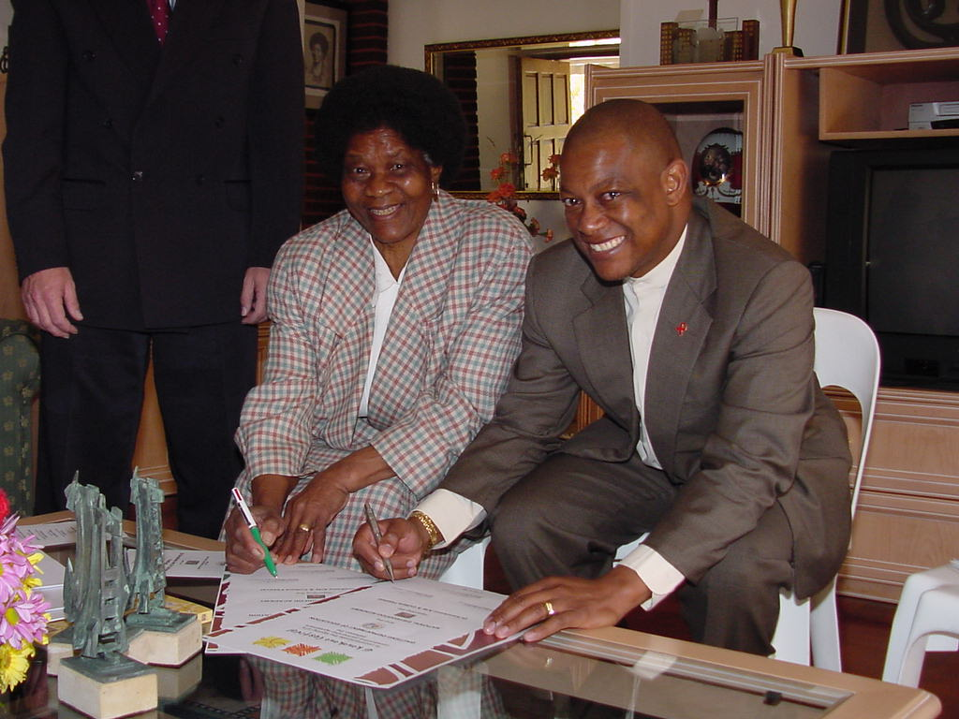

Albertina Sisulu (National Patron: Dikonokono Festival 2002 - 2011) & Malele Petje (CEO: Gauteng Department of Education) at the signing of the Constructive Partnership Agreement between GDE and the NEA on 12 August 2002

Present and Past Sponsors and Partners

The National Eisteddfod Academy acknowledge with great appreciation the following sponsors, partners and individual donors that supported and enabled the founding, development and growth of the organization as a vehicle for youth development in the arts.

SPONSORS 2020 - 2023
Sygnia Asset Management (Pty) Ltd
Unik Civil Engineering
Old Mutual Life Assurance Company

INDIVIDUAL DONATIONS
A total amount of R 35920 was received from the following individuals by way of once-off or monthly contributions since 29 July 2020 – 4 February 2023

N Loubser | Retha Coetzee | Donation | Stephanie Kasselman
Pro Musica Academy | National Eisteddfod | Micah Ribeiro | Terry Morris
Janina Rexr | Janina Rexr | S Pillay | Stephanie Kasselman
Nicolie Donation | Christen.Roux | Terry Morris | Terry Morris
N Loubser | Judy | Isabella Steynberg | Stephanie Kasselman
Stephanie Kasselman | Anastasia Kourtoumbellides | Tereza Fernandes | Terry Morris
Besky Ngujiri | V Theron | Stephanie Kasselman | Stephanie Kasselman
Beyer Family | Jaco Barnard | N & S Eykelhof | Terry Morris
R Jhagaroo | Megan & Kyla Coetzee | Donation | Stephanie Kasselman
Viljoen | Elna Moolman | Donation | Terry Morris
Kristian van Gaalen | Schraader | Donation | Stephanie Kasselman
Hade-Mari | Nicole Pears | Terry Morris | Terry Morris
N & S Eykelhof | Matthew Victor & Chloe Fernandes | Stephanie Kasselman | Terry Morris
KASSELMAN | Robyn Pears | Terry Morris | Stephanie Kasselman
Dawian van der Westhuizen | Weston Wang | Stephanie Kasselman | Stephanie Kasselman
Wian Conradie | Donation | Terry Morris | Stephanie Kasselman

SPONSORS 2018
National Lottery Commission for the “NEA Music, Dance and Theatre Development Project”

SPONSORS 2015
National Lottery Commission for the “NEA Indigenous Arts Development Project”
Roodepoort Theatre

SPONSORS 2014
Artslink.co.za
Roodepoort Theatre

SPONSORS 2013
Artslink.co.za
Arts and Culture Trust

PRINCIPAL SPONSOR 2010 – 2012
National Lottery Distribution Fund

OTHER SPONSORS AND PARTNERS 2009 – 2015

Artslink.co.za
National Arts Council
Rand Merchant Bank
Gauteng Department of Education
Damelin College Bramley
Academy College
Business and Arts South Africa
UNISA Music Foundation
Ekurhuleni Metropolitan Council
T.I.M.E.
Southdowns College
St. Andrew’s School for Girls
RMS Randfontein Rural Development Project
Primedia Lifestyle
Pieter Jacobs
Vukile Property Fund

Previous Partnerships
Gauteng Department of Education
The National Eisteddfod Academy signed a constructive partnership with the Gauteng Department of Education in August 2002.
This partnership accepted that the various disciplines in arts and culture constitute unique ways of knowing which should be developed in all learners. Consequently, exposure to and involvement in arts and culture activities is the right of each and every learner. Given the pressure on our limited resources, it is also accepted that we should take hands in sharing resources and know-how in order to achieve these goals for the benefit of all learners. Therefore it was agreed that the activities of the National Eisteddfod Academy should in no way be seen as being in competition or opposition with any other programme of the Education Department.

The strategic objective of this partnership was to support the Gauteng Department of Education in creating opportunities for development in and exposure to arts and culture for each and every learner in Gauteng in order to:

- Expose and develop learners in the various art disciplines in order to tap on hidden talent
- Create an awareness of arts and culture values in schools and communities
- Develop educators through active involvement in arts and culture programmes
- Develop awareness of career opportunities in arts and culture
- Promote equity and redress imbalances of the past in arts and culture activities
- Promote awareness and pride of our multi-cultural diversity.

National Arts Council
7 February 2022 - The National Arts Council announced that the National Eisteddfod Academy has been selected as a provincial partner to participate in The NAC Provincial Partnership Programme – Capacity Building Workshops.
ADJUDICATORS’ FORUM

The Adjudicators’ Forum is an activity of the National Eisteddfod Academy, founded with the vision to strive for the upliftment of the self and community through the education and celebration of the performing and creative arts. The Adjudicators’ Forum achieves this by providing a platform for deliberations, discussions and training regarding the adjudication of the performing arts. In doing so the Adjudicators’ Forum acts as representative body to safeguard and promote the interest of the individual adjudicators and participants alike.

The objectives of the Forum are to:
- manage the activities of the Forum in a way beneficial to the arts in general.
- set guidelines and criteria for adjudication.
- set and maintain a Code of Conduct for members.
- provide support to the NEA regarding adjudication, relevant procedures and syllabi.
- advise the management of the NEA regarding the appointment of adjudicators.
- provide training to aspiring adjudicators and educators.

Membership of the forum is open for all citizens of the Republic of South Africa and any interested individuals may apply for membership. For more information contact the NEA Office or send an e-mail to edu@eisteddfod.co.za.

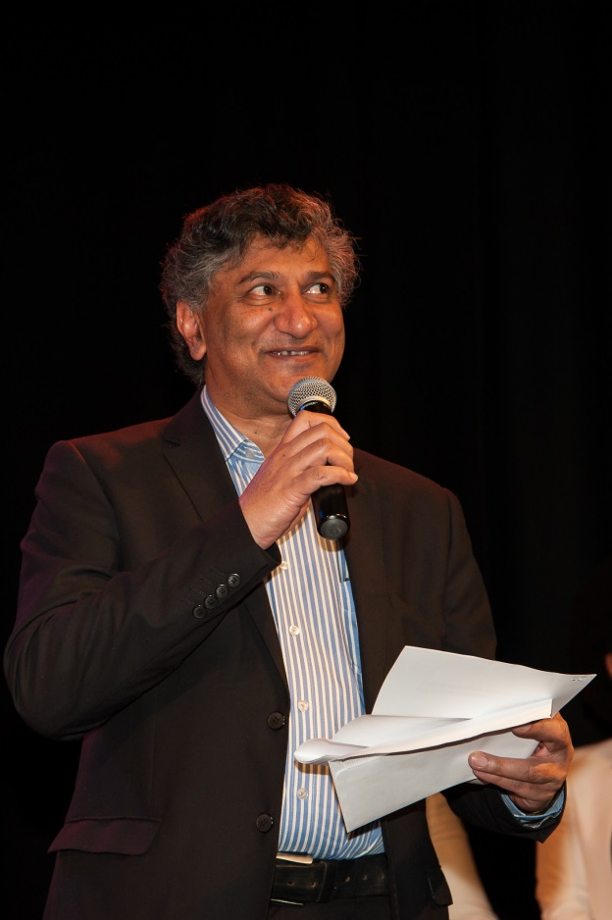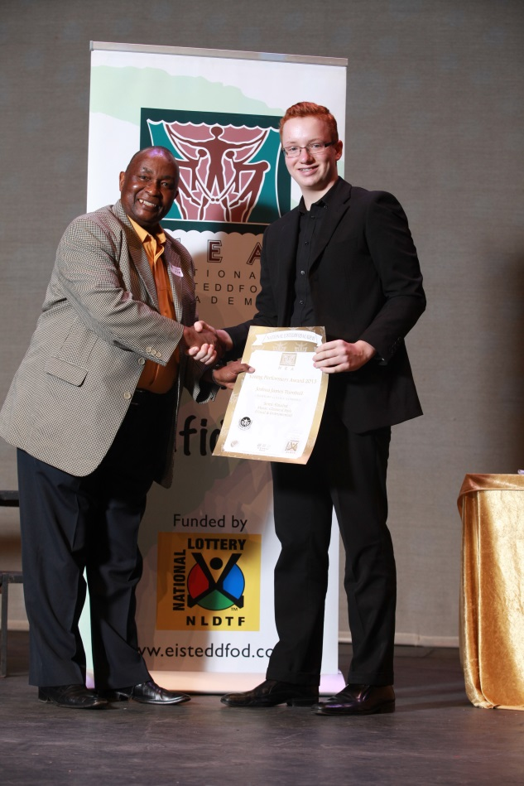

Mr Ismael Mahomed – Mr Dan Lefoka
Adjudicators’ Panel NEA Awards 2013 NEA Board Member and Music Adjudicator

PROGRAM OF EVENTS FOR 2026

NATIONAL EISTEDDFOD OF SOUTH AFRICA®: REGIONAL ACTIVITY DATES FOR 2026

Activity dates for the National Eisteddfod are not cast in stone and fall within the broad time frame from August – October as determined by school terms (4 term public / Private schools and 3 term Private schools).

The feasibility of adjudication sessions as provided by the National Eisteddfod Academy in any of the existing or new region depends on:
- the number of entries (at least 30 entries in any particular genre is required)
- the availability of venues within a particular region.

NEA YOUNG PERFORMER &

YOUNG ARTIST AWARDS COMPETITIONS 2026

PLEASE NOTE:
All Diploma recipients of the previous year (excluding reading and improvised / unprepared categories) qualify to enter for this competition. Qualifying plays and other larger productions may only be entered in the form of an extract.

Young Performer Awards Competition: Closing Date for Entries 2026
04 March 2026

Participation Dates NEA Young Performer Awards Competition 2026

FIRST ROUND | QUARTER FINAL ROUNDS | SEMI-FINAL ROUNDS | FINAL ROUND
9 – 20 March 2026 | 23 – 27 March 2026 | 7 - 8 May 2026 | 10 May 2026

VIDEO RECORDED ENTRIES:
- Recorded entries allow talented performers anywhere in the country to participate in the first and second rounds without the need to travel to Roodepoort. This will cut costs for these participants significantly.
- A panel of adjudicators will adjudicate all events and recordings.
- The feedback for “recorded performances” will be e-mailed to the relevant participants.
- Participants should take careful note of the requirements for recorded entries. The requirements for recording a video entry is available on the NEA website. (www.eisteddfod.co.za).
- Participants that proceed to the Semi- or Final rounds will have to perform “live” in this rounds.

CLOSING DATE FOR EISTEDDFOD ENTRIES IN 2026

The entry fee is determined by the mode and date of submission. A lower fee is charged for entries submitted online than in hardcopy format.

For full details of the entry fees, please refer to Part 13 of Prospectus 2026
- In order to qualify for the fee as provided,, proof of payment should reflect a date before the cut-off date of the various entry types (e.g. Early Bird, etc.)

Online Entry: Online Early Bird entry: (Live / Virtual / Video & Art) 31 May
Online Standard entry: (Live / Virtual / Video & Art) 30 Jun
Online Late Bird entry: (Live / Virtual / Video & Art) 31 Jul
Online Lost Bird entry: (Live / Virtual / Video & Art) 31 Aug
Online Final Deadline for Video & Art Entries: 18 Sep

Hardcopy entries: A higher entry fee is charged for a hardcopy entry
Hardcopy entry: (Live / Virtual / Video & Art) 30 Jun
Hardcopy - Final Deadline for Video & Art Entries: 18 Sep

IMPORTANT: Details of participation will be published online.

Submission of video and art entries:
Video and art entries will be adjudicated in three sessions. Video entries should be submitted on YouTube before any one of the following dates. A link to the YouTube video should be emailed to entry@eisteddfod.co.za. (See “Other Fees and Charges for 2024” on the next page for contact and banking details, as well as more info regarding per hand and courier delivery.)

- Session 1: 31 Jul 2026
- Session 2: 31 Aug 2026
- Session 3: 18 Sep 2026

* An extension of closing and submission dates (if any) will be announced on the website and on Facebook

All unprepared items (e.g. Unprepared Reading, Improvisation, etc.) CANNOT be submitted as video entries.

REQUIREMENTS FOR PARTICIPATION IN EISTEDDFOD 2026:

SUBMISSION OF REGISTRATION FORM IS REQUIRED:
- All institutions / studios / independent parents or participants must register ONLINE or download, complete and submit a Registration form
- Kindly note: Registration is free of charge.
- Registration is essential for management purposes (processing of entries, scheduling, invitations, etc.).

SUBMISSION OF ENTRIES IS REQUIRED
- Entries can be submitted as follows:
  - Online (via the NEA website www.eisteddfod.co.za)
  - By completing and submitting an entry form (by hand, fax or mail) (please refer to entry fees above!)
- Entry fee or proof of payment is to be submitted with the entry. No entries will be processed if entry fees are outstanding.
- Entry fees are not refundable.

OTHER FEES AND CHARGES FOR 2026

Any changes of closing dates / fees will be announced on the website www.eisteddfod.co.za

Cost of changing item numbers and/or names of participants
  - The NEA accepts NO responsibility for incorrect entries as it is the participant’s responsibility to ensure that the information provided ONLINE or on the entry form is correct.
  - Participants often only become aware of incorrect entries once they receive their details of participation. To prevent the additional cost of requesting the correction and reprint of certificates in these instances (R 32 per certificate!) participants are urged to request any changes regarding entry numbers and/or names of participants in writing to entry@eisteddfod.co.za. (IMPORTANT: A copy of the participant slip(s) with the incorrect data should be attached).

Entrance fee at venues:
- Entrance fees are an essential component of the NEA’s operational income and is necessary to cover the cost of venue assistants and basic venue fees.
- An entrance fee of R 71.00 per person will be charged at venues. Seasonal tickets will be available at R 155.00 each.
- A higher fee of R84.00 per person will be charged at some specialized venues for contemporary music and dancing to cover the additional cost of sound engineers and rental cost of these venues. Admission for participants, pre-schoolers or learners in school uniform is free.

Distribution of printed certificates for video entries:
- Hard copy prints of certificates awarded to video recorded entries can be collected on request from the NEA Office of will be forwarded on request to participants via PostNet at a cost of R109 per incidence once proof of payment has been received. Please email admin@eisteddfod.co.za with requests in this regard.

CONTACT AND BANKING DETAILS

NATIONAL EISTEDDFOD ACADEMY NPC

TEL: (011) 886-6005

E-mail address for the submission of entries: entry@eisteddfod.co.za

Physical address for hand deliveries of entries, art works and videos:

Bergzicht Office Park, Block 3, Suite 15, Crn Rooibok Str & Christiaan de Wet Ave, Allen’s Nek.
Postal address for sending entries, art works and videos

PostNet Strubens Valley, Shop 22 Retail Crossing,
Cnr. Nic Diederichs Boulevard & Hendrik Potgieter Dr.
Wilgeheuwel, Roodepoort, 1724. Contact number: 011 475 0452 / 0481

Bank details for direct bank / internet deposits:

ABSA, Clearwater, Branch code 632 005
Account no. 404 747 8448 (Current account)
Important! E-mail proof of payment to the e-mail address above.
Online entries: please quote PAYREF number and / or the name of the participant and institution.

RULES AND REGULATIONS

ASPECTS TO CONSIDER WITH ENTRIES

By submitting an entry for an event in the annual activities of the NEA, the participant agrees to the Rules and Regulations of the National Eisteddfod Academy pertaining to the annual Eisteddfod as outlined in this Prospectus and accepts the decision of the NEA management about all matters regarding this event as final.

CONDITIONS

- The eisteddfod is open to everyone, on the following conditions:
  - There are no limits to the number of entries a participant may partake in.
- Participants should observe the time allowed per item as outlined in this Prospectus.
- Participants should adhere to copyright where applicable.
- The NEA and its host venues are indemnified against any loss, theft or injury sustained during the festivals.
- Participants agree to adhere to the Rules and Regulations in this section, as well as the specific guidelines provided at the beginning of each section in this Prospectus.

“GRADING” AND AGE

- Each participant will be adjudicated on his/her performance, and not according to what is assumed that other learners of his/her age can do. The application of this principal is non-negotiable.

ENTRY FEES

- The correct amount should accompany all entries. No entries will be processed if the entry fees are outstanding.
- Entry fees are not refundable.

ONLINE SUBMISSION OF ENTRIES

The NESA.org.za ONLINE platform provides for the online submission of entries at a lower entry fee. The link to the online platform is available on the NEA webpage www.eisteddfod.co.za. Please note that “hard copy” entries (entries submitted on paper or by email) are subject to a higher entry fee.

SUBMISSION OF ENTRIES ON “HARD COPY” ENTRY FORMS

KINDLY NOTE: It is the participant’s responsibility to use the correct form, to ensure that he is entered for the correct item and that the information submitted on the entry form is correct, including the spelling of names. The category and item number needs to be filled in accurately. Refer to Other Fees and Charges for cost implications of incorrect entries.

Entries may be submitted by using any of the following methods:

Kindly take note of the difference in entry forms to be used for individual, small groups and large group items.

- Individual entries: All entries for a particular participant could be provided on the Entry Form for Individual Entries, where possible. (One entry form can be used for multiple entries per individual.) Use more forms when necessary.
- Ensemble and Small Group entries: The Entry Form for Small Groups should be completed for all entries involving 2 – 10 participants. The names and contact details of all the participants in the group should be provided on the form.
- Medium and Large group entries (11 or more participants): All entries for medium / large groups should be recorded on the Entry Form For Large Groups. Only one entry should be recorded per form. (The names of the members of the group should be forwarded in MsExcel or MsWord format if personalized certificates for each member of the group is required). The exact number of members in the group should be provided on the form.
- Multiple entries using the same item number (e.g., a teacher entering a whole class for prescribed poetry): When using this form, it is important to provide the date of birth and cell phone number of each participant (if at all possible!).
- Kindly refer to the guidelines on the completion of the entry form at the beginning of each section.
- The highest grade of a participant determines the grade for the group.
- A separate entry form should be completed for each individual participant/small group/large group.
- All the information as required should be provided (including date of birth and cell phone numbers).

Hard copies of the completed entry forms may be submitted to the NEA before the closing date in any of the following ways:
  - Hand delivered to the NEA office, Block 3, Suite 15, Bergzight Office Park, 15 Rooibok Str., Allen’s Nek
  - By e-mail to entry@eisteddfod.co.za.

CLOSING DATE FOR ENTRIES
Different dates apply for Online and hardcopy / emailed entries.
Refer to the Programme of events section for more details.

(Any changes to these dates will be announced on www.eisteddfod.co.za and Facebook.)

LATE ENTRIES

- An earlier date for hard copy entries (paper, e-mail) applies due to the fact that these entries need to be captured and checked in order to finalize the participation schedules on time.
- Hard copy entries (on paper or e-mailed) submitted after the closing date for entries will be accepted subject to the payment of a Late entry charge. Proof of payment should be submitted with the entry. Alternatively entries may also be submitted online at no extra cost until the deadline for online entries comes into play.
- Changes to the closing date for entries (if any), will be announced on the website.
ADJUDICATION

- The corporate strategy of the NEA is to set and maintain the highest levels of integrity and credibility in the adjudication of the various events at the annual festival. The NEA annually presents training and moderation sessions for adjudicators in an attempt to establish uniformity in adjudication standards as far as are humanly possible.
- Management will appoint the most competent adjudicators in all respects. Management will accept their decisions as final.
- Experience over years has proved that discontent with the outcome of an adjudication session has more to do with an “unfulfilled anticipated outcome”, than with the credibility of the adjudication.
- Experience has also shown that the qualifications and judgment of an adjudicator that awarded mostly diplomas during any session has never been questioned.
- NO person may approach the adjudicator before / during / after the session to discuss the outcome of the adjudication, particularly in the instance when he/she is unhappy with the outcome. Should this happen, all proceedings will be stopped immediately and this person will be ordered to leave the room and will not be allowed to attend any further performances. Proceedings will continue once order has been restored.
- However, the NEA considers any feedback on events and adjudication as of critical importance in maintaining the integrity and credibility of the organization. Therefore all complaints should be submitted in writing and should be accompanied by the report form of the adjudicator in question, within 7 days of the event, for Attention: The CEO, National Eisteddfod Academy (Fax: 011-787-3534; e-mail: info@eisteddfod.co.za.). Kindly note that NO complaint will be dealt with telephonically.
- When possible, all issues that can be dealt without delay will be resolved immediately. Please do not necessarily expect written feedback in these instances.

OWN CHOICE

- A copy of own choice material should be available if requested by the adjudicator.

MAXIMUM DURATION OF PERFORMANCES

- Participants are not allowed to exceed the maximum time limits as allocated per item. Adjudicators have the right to terminate ANY performance that exceeds the maximum limit as it could impact negatively on the flow of the programme and will cause the remainder of the programme to run behind schedule.

DEFINITION OF PHASES

- Foundation phase : Grades R – 3
- Intermediate phase : Grades 4 – 6
- Senior phase : Grades 7 – 9
- FET phase : Grades 10 - 12
- Primary school level : Any combination of grades on primary school level (Gr. 0 – 7)
- Secondary school level : Any combination of grades on secondary school level (Gr. 8 – 12)
- Open section : Out of school (past Gr. 12).

DUPLICATE ENTRIES OF THE SAME ITEM

- No participant may enter and perform the same item in more than one area of the National Eisteddfod in a given year.
- There is no limit on the number of entries per category.

SCHOOLS/STUDIOS

- All participants entered under the name of a school should be bona fide learners of that specific institution.
- Schools should acknowledge studios where applicable and vica versa.
- When learners from a registered member are entered privately, those entries will be grouped with the other entries received from that registered member.
- When applicable, studios are kindly requested to provide the name of the relevant school for each participant on their entry forms.
- Only schools / institutions / studios that have registered with the National Eisteddfod Academy can be acknowledged on certificates.
- The NEA database provides for acknowledgement of both the school and trainer. The name of the school as well as the studio will be printed on the certificate if this information was provided on the entry form.
- Participants will be scheduled according to the region as selected by the school.

SCHEDULING OF EVENTS

- Any special requests regarding the scheduling of events should be submitted with the entries, but NOT LATER than the closing date for entries. IMPORTANT: Any special request should be submitted on the SPECIAL REQUEST FORM.
- Details of participation will be published online and will be e-mailed ONLY to participating bodies that requested it on their registration profile, 2 weeks prior to the participation date. Participants should not wait for this information before they start their preparations for their relevant items and should rather prepare in advance in order to be ready to perform on the first day in each region!
- It is the participant’s responsibility to provide the correct entry number. Failure to do so will result in the processing of incorrect information for which the NEA is not accountable. Once the schedule has been finalized, no changes can be accommodated.

SPECIAL REQUESTS

- Any special requests regarding the scheduling of events should be submitted with the entries, but NOT LATER than the closing date for entries for the particular region. IMPORTANT: ALL special request should be submitted on the SPECIAL REQUEST FORM. The NEA will endeavour to accommodate these circumstances whenever possible, but cannot give any guarantee in this regard.

HOW AND WHERE WILL THE PERFORMANCES TAKE PLACE?

Live Performances: Events will be scheduled at available venues according to the REGION and LOCAL AREA, as selected by the institution, studio or individual upon registration. All events that cannot be accommodated at appropriate venues within the selected LOCAL AREA, will be scheduled at appropriate venues within the selected REGION. This could possible the case with events that require specialized venues (e.g. classical music, contemporary music with backing tracks and dance events).

Video Recorded Entries: Recorded entries will be adjudicated at the NEA Office or at a venue where the videos can be viewed as arranged by the NEA office.

SPECIAL ENTRIES

The NEA always attempts to accommodate the needs and requests of all participants. Therefore participants have the option to submit special requests pertaining to unavailable dates in the eisteddfod period.

In order to provide for unforeseen circumstances, the NEA provides specific procedures that those candidates who have missed events as originally scheduled, should follow. Details regarding these “Special Entries” will be published on the website. Participants should also note that any changes to the original date of performance will have cost implications.

No correspondence and requests pertaining the “rescheduling” of events other than these procedures will be allowed.

GUIDELINES FOR PARTICIPANTS & PARENTS

- As every participant deserves the opportunity to be a champion in his own right, kindly take note of the following:
- All officials & participants should be treated the way you would like to be treated.
- Venue controllers will allow no changes in the programme.
- For obvious reasons, NO participant/parent/trainer/member of the audience may approach the adjudicator before/during/after a session.
- NO person may approach the adjudicator before / during / after the session to discuss the outcome of the adjudication, particularly in the instance when he/she is unhappy with the outcome. Should this happen, all proceedings will be stopped immediately and this person will be ordered to leave the room and will not be allowed to attend any further performances. Proceedings will continue once order has been restored.
- No refreshments or smoking will be allowed in the venue.
- All cell phones should be switched off in the venue.
- Entrance fees:
  - Entrance fees are an essential component of the NEA’s operational income and is necessary to cover the cost of venue assistants and basic venue fees.
  - For more information in this regard please refer to OTHER FEES AND CHARGES.
  - Admission for participants, pre-schoolers or learners in school uniform is free.

GUIDELINES FOR SELECTING MATERIAL

- Given the wide spectrum of age groups and categories provided by the NEA, as well as the diverse possible combination of items when scheduling events, participants should note that vulgar language is generally not accepted in any category.
- Any presentation containing material that could disturb members of the audience, could be permitted only when used with discretion, provided that the material forms an integral part of the text, justifiable within the context and the NEA is informed in advance so that it can be considered when scheduling the event. The participant should also warn the audience prior to the said presentation that the presentation contains material that could be disturbing to members of the audience.
- No questionable content or language will be allowed at public events like Showcase events and all the sessions of the Young Performer Awards competition.

GUIDELINES AND REQUIREMENTS FOR VIDEO RECORDED ENTRIES

Please refer to the website for details regarding the deadline for the submission of video recorded entries.

What is a video recorded entry?
- A VIDEO RECORDED ENTRY provides for the recording of any performance that would usually be performed on a stage (or suitable venue) in instances when the performance cannot be presented live in the presence of an adjudicator for the adjudication of the event.
- A Video recorded entry allows participants in remote areas where the adjudication of live performance is not possible with the opportunity to participate in the National Eisteddfod of South Africa.
- A Video recorded entry also provides an alternative solution for participation when live performances is not allowed or people might not feel comfortable with, as during the Covit-19 lockdown period.
- All videos should be recorded according to the guidelines as provided in this document.

Submission of video recorded entries

Two options are available for the submission of the recorded performance:
- Electronic transmission of video via a YouTube Channel.
- Submission of a video on a DVD or Flash Drive by mail / courier service or delivered by hand.

Summary of processes:
Electronic submission:
- Various options exist for sharing a video electronically, however submission via YouTube is preferred due to the ease of sharing videos with adjudicators for adjudication purposes.
(Videos shared by YouTube link lives in the channel of the sender. Please note that WeTransfer and Dropbox submissions are NOT ACCEPTED.)
- Share your links (ONE entry and entry form at a time!) to entry@eisteddfod.co.za .
- Attach proof of payment with each entry.
- Refer to the How to send your video with YouTube section for instructions in this regard.

Submission by mail / courier services:
- Copy your video recording on a Flash disk
- Only ONE performance should be copied on a DVD. Use a separate DVD for EACH entry / recording.
- All Flash disks should be clearly marked with the NAME & SURNAME of the participant(s)
- Flash disk entries can be hand delivered / mailed / couriered to the address as provided in this document.

Guidelines for recording the performance
- IMPORTANT! All submissions for the National Eisteddfod of SA should be recorded in the format as outlined below (see recording your performance). No performances recorded at any other event (concert, show, etc.) will be accepted for adjudication.
- A professional recording is not required. Any reference to “camera” includes both a traditional video camera or a smartphone, tablet or computer with video capturing facilities.
- Please note that NO editing of a recording is allowed, e.g. “tweaking” of intonation errors, etc.

SETTING THE “SCENE”
- The camera position should represent the "eyes of the adjudicator", without zooming in and out, moving around with the camera, changing of camera angles, etc.
- Position the camera where the full performance area as utilized by the performer, will be visible in the view finder or on the screen. If necessary, zoom in/out until this can be obtained and then leave the camera stationary.
- Background:
Make use of a plain or neutral background as far as possible. Be aware of the contrast with the background, e.g. do not perform with a black costume against a black backdrop.
- Lighting:
Please ensure that there is sufficient light on stage or wherever the performance is being recorded. Light should come from the front to prevent shades on the face(s). (Important: do not record in front of a window with the light coming from the back.) Refrain from using lighting effects when recording drama items. Lighting effects may be used when recording dance or contemporary music items as long as it does not affect the visibility of the performance. (It is difficult to adjudicate a performance that happens in the dark!)
- Acoustics:
Acoustics refers to the audibility of the sound in the room where the performance is recorded. The clarity of sound is of particular importance when recording speech items. A large empty room or any room without absorbent material (e.g. curtains, carpets, and soft furniture) will create a considerate amount of reverberation (echoing caused by the deflecting of sound from one wall to another, thus creating a very “live” acoustical environment.) Although a level of reverb is often preferred for musical items, it is detrimental for clarity of speech and should be avoided.
- Sound balance (when applicable):
Please ensure that the accompaniment (live accompaniment or recorded backing tracks) does not outshine the voice(s) when recording vocal and instrumental items. The recording should display a good balance between the voice/instrument and the accompaniment.

Recording your performance:
- Prepare your label: You need the following:
  - One page per item - A3 or A4 size white paper
  - Thick black marker pen.
- Provide the following information on your label (please print clearly!)
  - Your NAME & SURNAME, Grade & School (where applicable),
  - ENTRY NUMBER and a
  - BRIEF DESCRIPTION OF THE ITEM (e.g. English Monologue, Vocal solo, Jazz, etc.)
- Prepare for your recording and hold this "label" up in front of the camera so that the detail is clearly readable in the view finder and keep it there. Start the recording by pushing the record button and hold it for a count of 10 and then pause the recording. Get rid of the white page and move into the starting position for your performance. Then push the record button again and continue with the performance until the end. Do not at all stop or pause the recording during your performance. If anything goes wrong, you need to start all over again, including holding up the "label".
- When using a traditional video camera, follow the procedure as required by your camera to import the recording from the camera to your computer.
- Rename the file to your {unique participant number} - {name} - {surname} – {item number}
- Do NOT edit the video.

How to submit the video recording on flash disk

COPYING THE RECORDING ONTO FLASH DISK / MEMORY STICK:
- Insert your flash disk and format if requested to do so.
- Select and copy the video file on your computer and paste into the flash disk folder.
- Close the file if necessary and eject the media in the correct way. (Don't just pull it out as it can cause corruption!)
- Re-insert your flash disk. Check if you can open and play the file (please check both image and sound!).
- If everything is fine, close the file and eject the media in the correct way.
- Final step: Put the flash disk stick clearly marked envelope, attach a copy of the entry form and put everything in a bubble envelop and deliver by hand or mail / courier to the address as provided below. More than one flash disk can be included in one envelope if needed. You are advised to register the envelope and to mail the tracking number to entry@eisteddfod.co.za together with a copy of the entry form and proof of payment.

Delivery / postal address:
- Flash disk entries can be hand delivered / mailed / couriered to the following address:
By hand: | Couriered by Postnet:
National Eisteddfod Academy  Bergzicht Office Park, Block 3, Suite 15  Crn Christiaan de Wet & Rooibok Str.  Allen’s Nek | PostNet  Strubens Valley, Shop 22 Retail Crossing, Cnr. Nic Diederichs Boulevard & Hendrik Potgieter Dr. Wilgeheuwel, Roodepoort, 1724  Contact number: 011 475 0452 / 0481

How to send your video to YouTube from your computer

STEP 1: Create a YouTube account or proceed to Step 2 if you already have one
How to create a YouTube account:

- Open your internet browser and add http://youtube.com in the address line:



This will take you to the YouTube homepage:
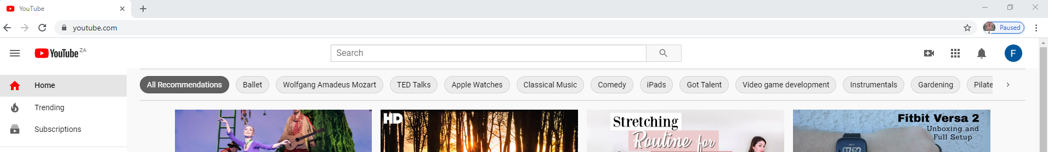

- Click on the SIGN IN button in the right-hand corner of the page:
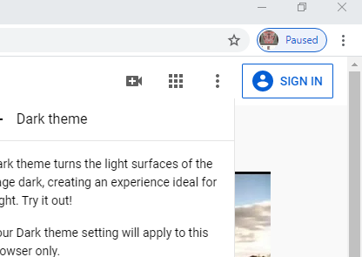

This action takes you to the Google “Sign in” page where you, if you do not have an existing Google account, now need to create one.

- Click on the CREATE ACCOUNT button.

- This brings up the “CREATE YOUR GOOGLE ACCOUNT” page.

Important: keep record of the email address that you have used, as well as you password!

You can create a new Gmail address if you wish or you may use you existing e-mail address for this purpose. This will call up the following verification process:

This email address will be your email address as used when creating the Google Account.

STEP 2: Creating a YouTube Channel

- Sign in to your new YouTube Account or open your existing account: open your internet browser and add https://youtube.com in the address line. Open the page and then click on the SIGN IN button in the right hand corner of the page:

- Enter the email address and password that was used to create your Google account.
Signing in opens up the YouTube Homepage:
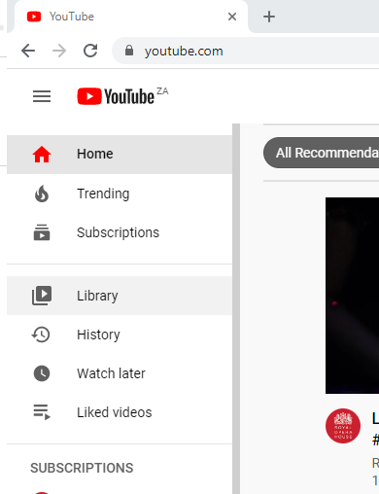
If you haven’t used YouTube before, you now need to create a YouTube Channel. Any action that requires a channel, such as uploading a video, etc. will now prompt you to do so.

- Clicking on the camera icon below may now prompt you to create a channel:


- Click on Upload Video


- Create a channel if required:

Your Name

STEP 3: Upload your video to your YouTube Channel

You are now ready to upload your video to your YouTube Channel. Before you proceed with uploading your video, please check if the following steps have been completed:
- Submit your entry ONLINE OR complete a copy of the hardcopy entry form. You will need a copy of this document in Pdf format.
- Pay your entry fees via EFT.
- Have a copy of the proof of payment in Pdf format ready.

- Once the channel has been created, you can now proceed with uploading the video by clicking on the camera icon in the right hand corner of the page.
- If you are new to YouTube, you might also encounter a number of other steps:


When you select the LEGACY UPLOADER, the following message will be displayed:
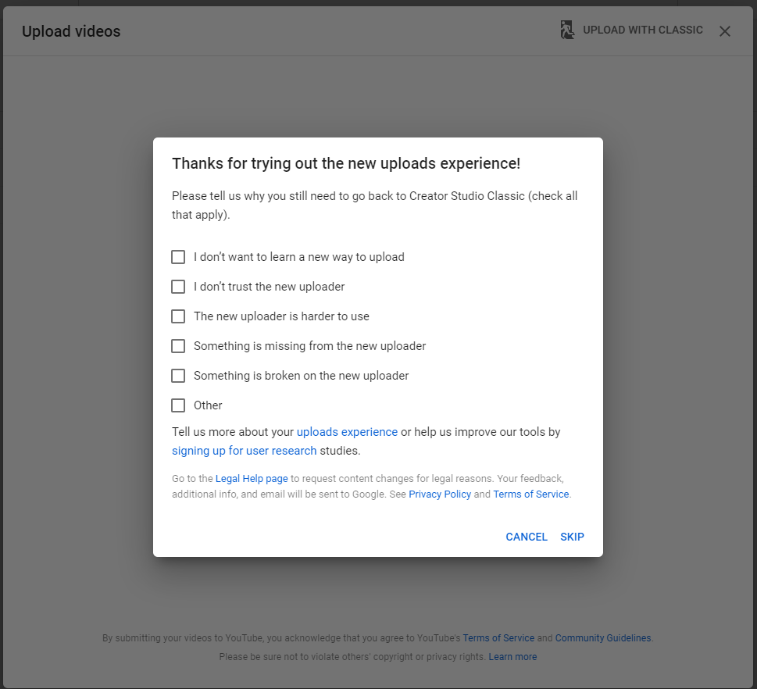

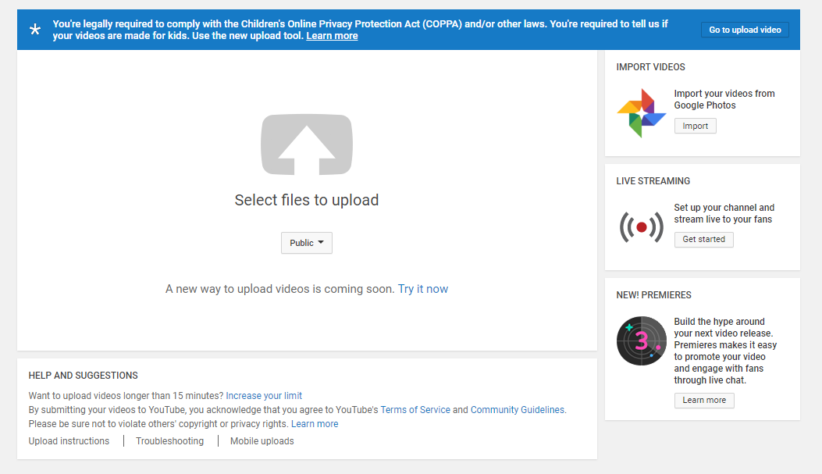
- Click on SKIP. This will bring up the following page:

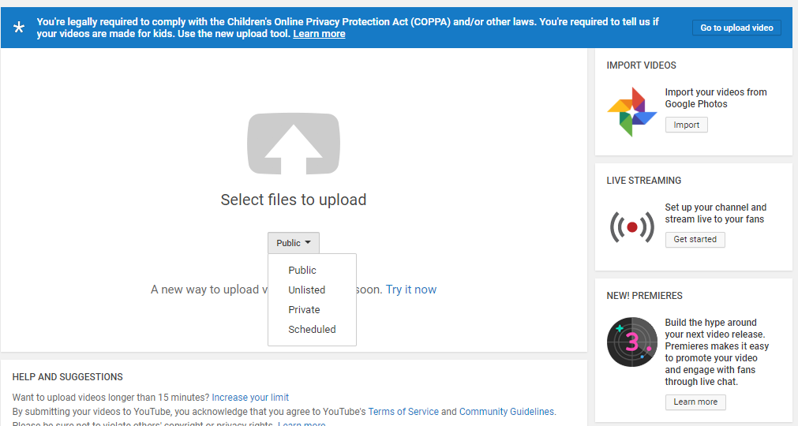
- Click on the arrow next to the “Public” button in the middle of the page. This will open up a drop box with the following options: Public, Unlisted, Private and Scheduled.

- Select the UNLISTED option. (This is IMPORTANT, however if you miss it here a next opportunity will be coming up soon!)
- Click on “Select files to upload”.
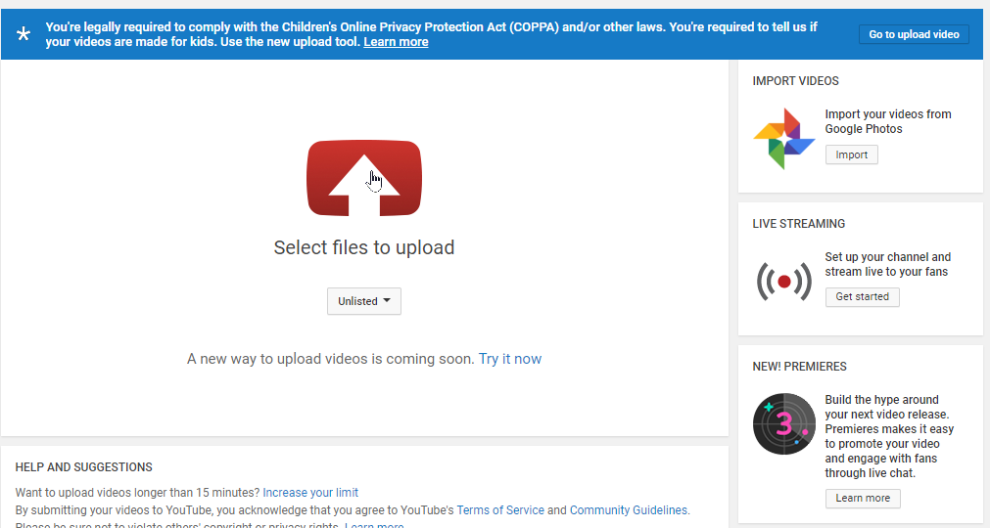
This will now take you to your computer where you have to locate the folder with your videos.
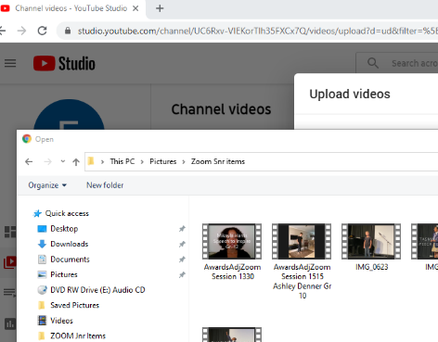
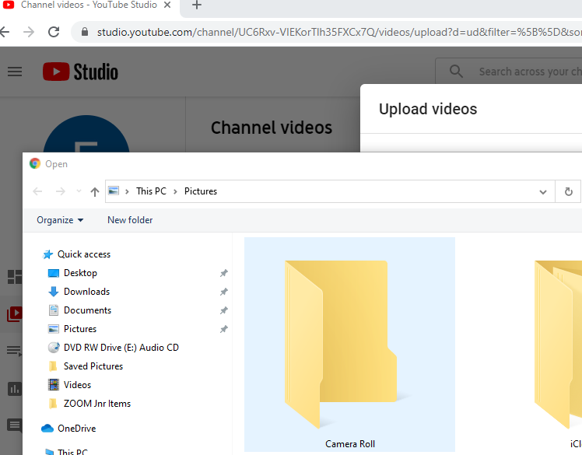
- Select the file that you want to upload and complete the details as required. Please note the guidelines and requirements as provided below:
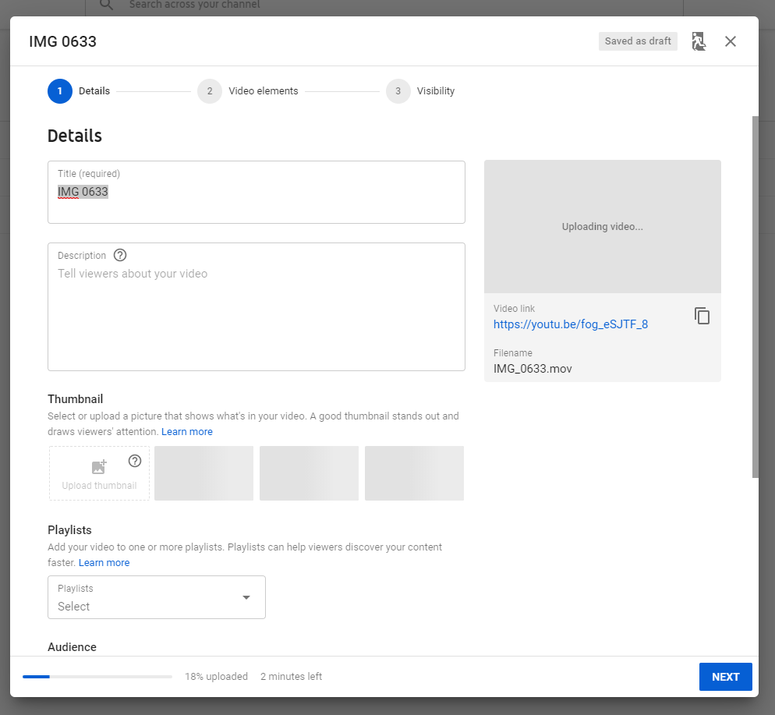
IMPORTANT:
For Large Group Entries provide the NAME of the GROUP as well as the NAME of the SCHOOL or STUDIO
Provide the full item description in the Description box. Where possible, also include the title of the song, poem, etc.
GROUP ITEMS: Please provide the names of all other group members here.

Add the following info as your video title:
Your Participant Number -
Your Name & Surname -
Item number

Ignore the Thumbnail and Playlist and scroll down to the Audience section and select “Yes, it is made for kids”

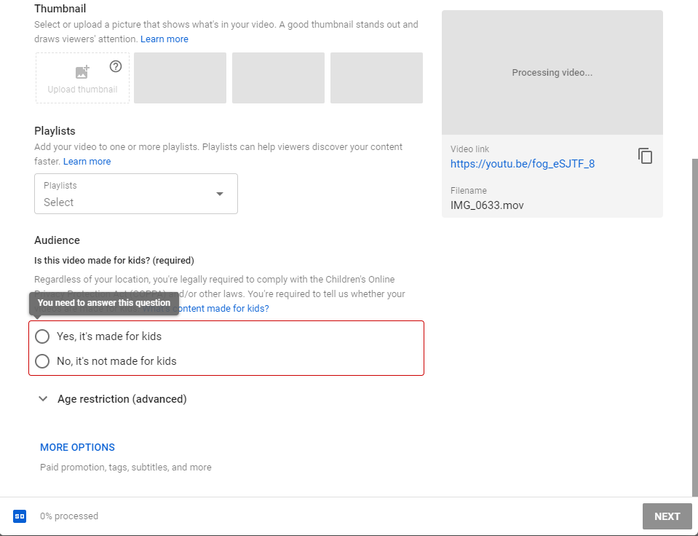
Important: Click the bullet “Yes, it’s made for kids.

Please ignore the “Video elements” section.
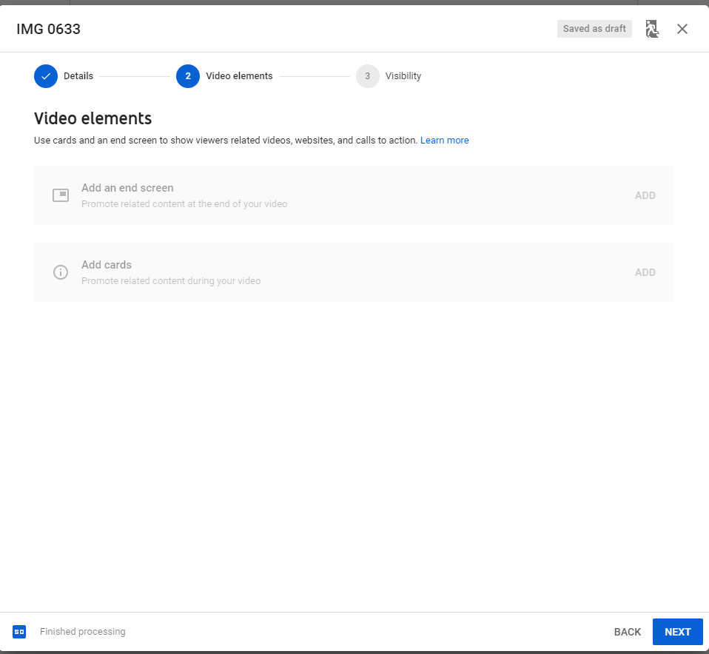
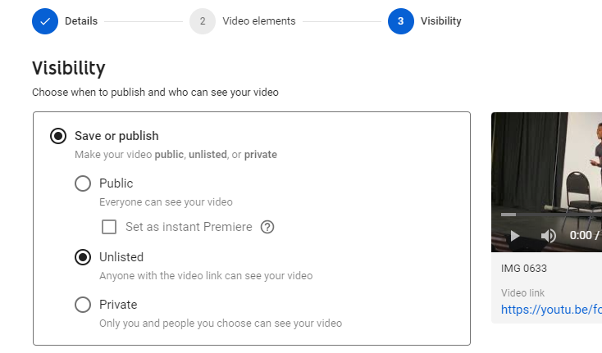
- If you haven’t selected the visibility option before, you can do so now by selecting the UNLISTED bullet below. (Without selecting this option, we will not be able to view your video).

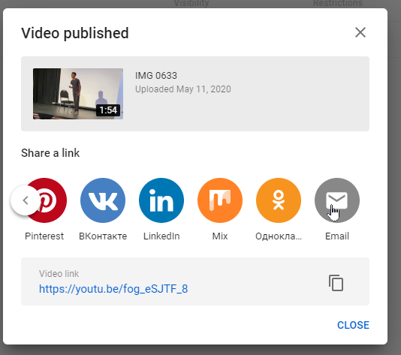
- You will receive a Video published message with the following options as soon as uploading has been completed. You have now reached the final steps!
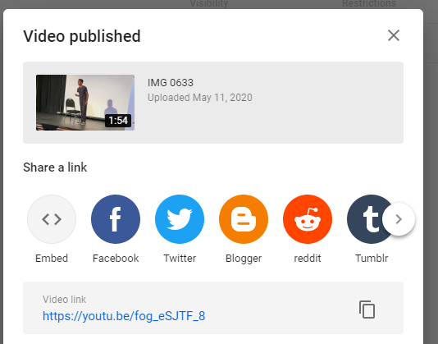
You can also COPY the video link HERE and then add it in a new email

- Click on the “>” to the right (next to the Tumblr icon) to bring the EMAIL icon into the view. Next click on the EMAIL icon to display a blank email message that contains the link to your video.
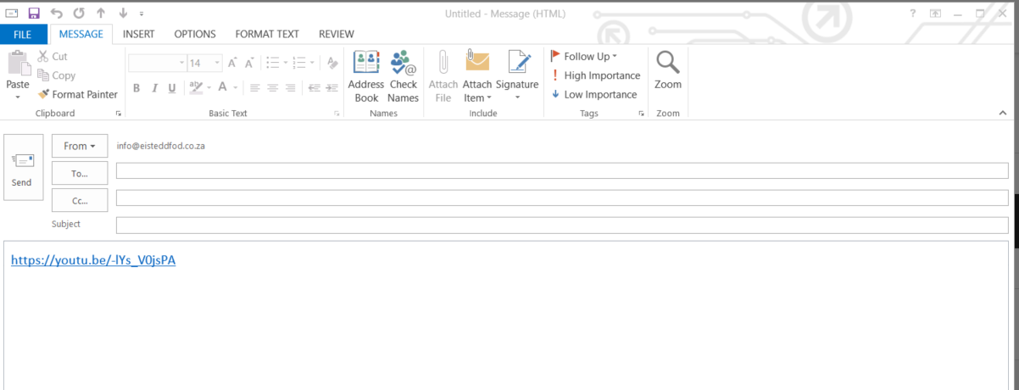
IMPORTANT: do NOT edit, change or delete this link!

STEP 4: Submit your video link
- Add the following information to a blank email that contains your video link:

- In the “To” address add entry@eisteddfod.co.za
- In the “Subject line” add the following information in the format:
[Number] – [Name] - [Surname] – [Item Number]
  - Unique participant number -
  - Your Name & Surname -
  - Your Item Number
  - FOR LARGE GROUP ENTRIES ONLY:
    - Name of the Group & Name of School / Studio & Item number
- Click on SEND to complete the process (for peace of mind, please activate the Delivery/Read requests on the OPTION button above. NB: This will eliminate the need to check if the mail was received or not!)

- Finally click on the close button.
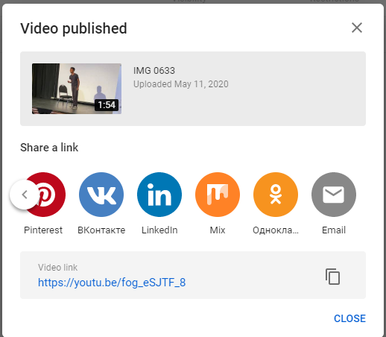
Your video is now uploaded to your Channel. Do NOT edit, change, move or remove this video. (You may still view or share it) If you do make ANY changes, the NEA will NOT be able to access or adjudicate your video with the link that you have emailed to entry@eisteddfod.co.za.
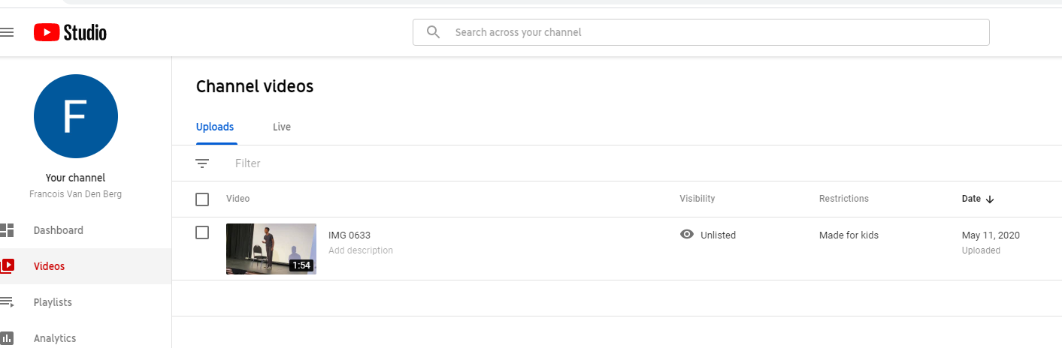

How to send your video to YouTube from your Smartphone
You need a Google Account to sign into YouTube. A Google Account works across all Google products (like Gmail, Maps, YouTube, etc.). If you have used any of these products before, you already have a Google Account.
To sign in, enter the email address you used for those products. If you don't have a Google Account, you are going to create one now.
Here are a few important things to remember about Google Accounts and YouTube:
- You sign into YouTube with your Google Account. To sign in to YouTube, enter your Google Account email and password. After signing up for YouTube, signing in to your Google account on another Google service will automatically sign you in to YouTube.
- Deleting your Google Account will delete your YouTube data, including all videos, comments, and subscriptions.

Courtesy of support.google.com

Creating a YouTube Account – Android Device  - Open the YouTube app from your device    - In the top right, tap the profile picture .      - Tap Sign in using your google account credentials  Tap Add account  - If you're already signed in with a Google Account, but want to make a new one:  - Open the YouTube app.  - In the top right, tap your profile picture .  - Tap Switch account.  - Tap Add account  - Once you've signed in to YouTube with your Google Account, you can create a YouTube channel on your account. YouTube channels let you upload videos, leave comments, and create playlists.  Create YouTube channel-Android  Follow these instructions to create a channel that only you can manage using your Google Account.  - Sign in to YouTube on your mobile device.  - Try any action that requires a channel, such as uploading a video, posting a comment, or creating a playlist.  - If you don't yet have a channel, you'll see a prompt to create a channel.  - Check the details (with your Google Account name and photo) and confirm to create your new channel.    Your Name  Upload videos to your Android  Process 1  - Activate the phone's Wi-Fi. The best way to upload a video is to turn on the Wi-Fi connection.  - From the Apps Menu screen, choose the Files app.    - Select the video you want to upload and tap it for the menu options.  - Select the SHARE tab on some devices you find the Share tab under MORE in the menu options, and choose YouTube from the menu.  - Fill in the blanks to describe & Title the video  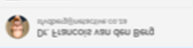  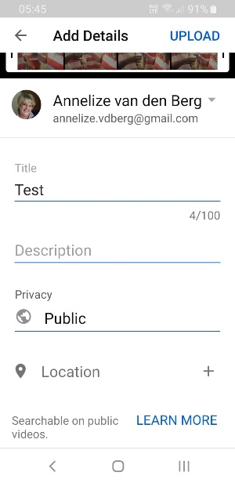  Add the following info as your video title: Your Participant Number - Your Name & Surname - Item number  Provide the full item description in the Description box. Where possible, also include the title of the song, poem, etc.  GROUP ITEMS: Please provide the names of all other group members here.  - Touch the Upload button or the send envelope on top   - Edit details  Select the Unlisted option on the Add details screen    Process 2  - Activate the phone's Wi-Fi. The best way to upload a video is to turn on the Wi-Fi connection.  - From the Apps Menu screen, choose the YouTube app.  - Click on the video camera icon on top.  - A list of all the videos on the device will popup  - Select the video you wish to upload  - Fill in the blanks to title, describe and privacy status of the video  Very important: PRIVACY select Unlisted  - Touch the Upload button or envelope sign on top depending on your device  - You are legally required to comply with the Children’s Online Privacy Protection Act (COPPA)  - If necessary, download and open the YouTube Studio App  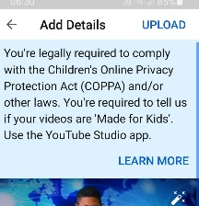 | Creating a YouTube Account – iPhone  - Open the YouTube app.    - In the top right, tap the profile picture.    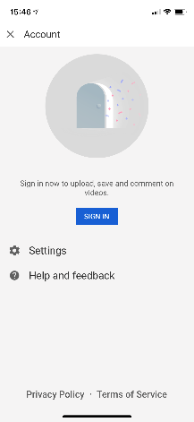  - Tap Sign in.  - If you already have an Account, tap on your account name or Tap Add account.  If you're already signed in with a Google Account, but want to make a new one:  - In the top right, tap your profile picture .  - Tap Add account.    - Tap Create account.    Create YouTube channel on iPhone  Once you've signed in to YouTube with your Google Account, you can create a YouTube channel on your account. YouTube channels allows you to upload videos, leave comments, and create playlists.  Follow these instructions to create a channel that only you can manage using your Google Account.  - Sign in to YouTube on your mobile device.  - Try any action that requires a channel, such as uploading a video, posting a comment, or creating a playlist.  - If you don't yet have a channel, you'll see a prompt to create a channel.  - Check the details (with your Google Account name and photo) and confirm to create your new channel.  Upload videos to your iPhone  - Sign in to your channel on the YouTube app.  - At the top of the app, tap the camera .  - Select an existing video from your gallery.  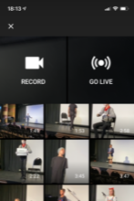  - Add a title (max 100 characters) and description (max 5,000 characters) to your video.  - Tap Upload to finish.    - Edit details  Add the following info as your video title:  Your Participant Number -  Your Name & Surname -  Item number  Provide the full item description in the Description box. Where possible, also include the title of the song, poem, etc.  GROUP ITEMS: Please provide the names of all other group members here.  IMPORTANT:  For Large Group Entries provide the NAME of the GROUP as well as the NAME of the SCHOOL or STUDIO  Select the Unlisted option from the Privacy dropdown box.    - You are also legally required to comply with the Children’s Online Privacy Protection Act (COPPA).  - Download and open the YouTube Studio App  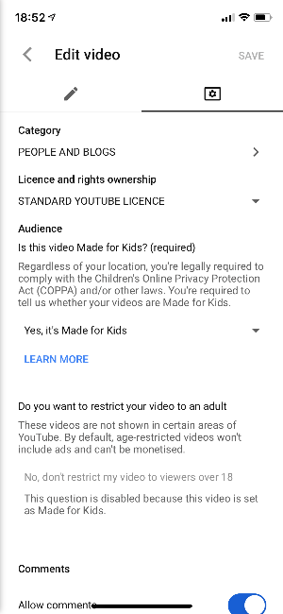    Select Made for Kids

ACKNOWLEDGEMENT OF ACHIEVEMENT

CERTIFICATES & DIPLOMAS

All participants that enter the annual eisteddfod organized by the NEA will be adjudicated by members of the NEA Adjudicators’ Forum. All participants will receive certificates (Diploma*, Gold, Silver or Bronze) according to the criteria as outlined below:

SETTING THE SCENE

Generally speaking an objective “measurement” of any performance in the arts is very difficult, if not impossible. Ample examples of this are to be found in the arts industry/ professional world where a performance might be applauded by one and despised by another review.

Within this context it is of critical importance to be reminded that the NEA considers the eisteddfod process to be an educational and developmental tool that promotes the interests of both the participant in particular and the arts in general. The adjudication of any event should then sensibly provide for the basic human desire for recognition when adjudicating and giving feedback to the

- talented learner (who might follow a career in the arts and who requires meaningful feedback);
- majority of participants (who might become the future supporters of the arts, and who will gain self-confidence, assertiveness and the courage to take a stand in this world).

In doing so the adjudicator should never lie or give false feedback to any participant. At all times the individual achievement of each participant, within the framework of his own developmental phase, should be considered and acknowledged.

CRITERIA

Having said that, one can now consider the fact that the performance or presentation of any art work requires certain “measureables” or yardsticks that refer to the skills level of the performer and his/her knowledge and understanding pertaining to the ars form and particular piece. Within the unique makeup of each individual performer or artist, these elements work together in producing a result that can be rated in general terms as:

  - Excellent – above the typical / ideal level on most yardsticks
  - Good – well above the minimum level on most yardsticks
  - Acceptable - just above the minimum level on most yardsticks
  - Below Expectation - below the minimum level on most yardsticks

The critical challenge is to define an ideal or typical level of performance in the arts (in this context not to be confused with an idealistic / supreme / ultimate level). For this purpose the NEA considers this ideal or typical level to be when all the basic requirements pertaining to the objective measurables / yardsticks of the art form are sufficiently met and executed with ease. This stage lies well above the minimum level and goes hand in hand with a progression from “conscious awareness” to “unconscious unawareness”. The preceding level of “just above the minimum level” implies that the candidate is in the process of gaining control, although this might not always be well maintained. In real terms the ideal level is probably the highest level that the majority of all participants might be able to achieve.

Given this frame of reference, the NEA system of awards and certificates can now be defined as follows:

- DIPLOMA is awarded for an excellent performance where the participant has performed above the ideal / typical level on most yardsticks – this is to say that the skills level, knowledge & understanding pertaining to the yardsticks / measurables are above the ideal / typical level. An excellent performance is not necessarily perfect in all aspects, however a performance on this level will most definitely display originality (“spark”), creativity and sincerity.

* A special Junior Diploma will be awarded to learners in Foundation Phase (Gr. 0 -3) to acknowledge the special requirements when working with small children.

Within the framework of the “diploma” the adjudicator has the freedom to express the level of achievement on a scale of 1 -10. (This information will be for the use of the NEA office only).

- GOLD is awarded for a good performance where the participant has performed well above the minimum level on most yardsticks – this is to say that the skills level, knowledge & understanding pertaining to the yardsticks / measurables are well above the minimum level. A good performance is not necessarily perfect in all aspects, but generally displays a high level of skills, knowledge & understanding pertaining to most of the yardsticks / measurables, as well as some initiative/creativity.

- SILVER is awarded for a performance that one can described as acceptable / satisfactory / adequate. The participant has performed just above the minimum level on most yardsticks – this is to say that the skills level, knowledge & understanding pertaining to the yardsticks /measurables are just above the minimum level. Although the basic skills, knowledge and understanding are present; the candidate has not acquired full control and still has to work on one or more of these aspects.

- BRONZE is awarded for a performance that is below expectation and indicates an performance below the minimum level on more than one yardstick. Although the candidate has developed some skills, knowledge and understanding relevant to the genre, it is still below the minimum level with regard to more than one aspect.

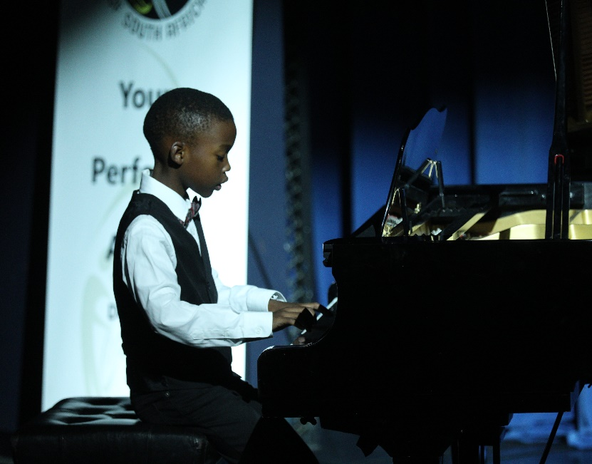
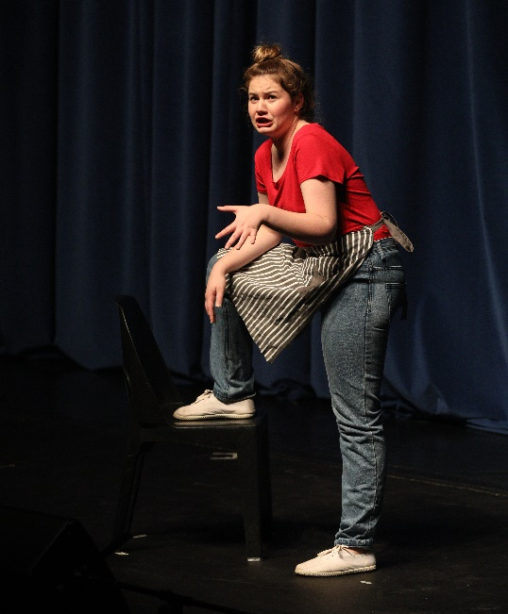

Lebeko Mosunkutu – Silver Medalist  NEA Young Performer Awards 2018 | Marielle Maritz – Bronze Medalist  NEA Young Performer Awards 2018

ADDITIONAL REGIONAL AWARDS

Over and above the certificates that will be awarded at each adjudication session according to the criteria outlined above, the NEA will also give special awards to participants that delivered outstanding performances during these events. These awards will be formally presented at the NEA Showcase Concerts in the different regions.

In order to identify the recipients of these awards, the NEA will consider the marks (%) as allocated by the adjudicators. (Although no % marks are recorded on the feedback to participants, adjudicators are required to record these marks for use by the NEA office only.) The NEA reserves the right to change the minimum requirements of any award without notification. Additional awards include the following:

ITEM WINNER CERTIFICATES

- A participant with the highest mark (%) in any given item in a region will receive an Item winner certificate, stating e.g. that he/she was the item winner in Narrative Poetry, Gr. 1. Other examples of items are the following: Narrative Poetry, Gr. 2; Classical Ballet Solo, Gr. 7; Vocal solo, Inspirational music with backing track, Gr. 8; etc.
- Should a participant be the winner in more than one item, all these achievements will be listed on one certificate, although the implication is then that each event that he won, warrants a separate award.
- Minimum requirement: Achievement on diploma level (91% and higher).
- When there were many entries and adjudication of any given item was done over more than one session, all the entries for that item are grouped together in order to determine the winning candidate (i.e. participant with the highest mark).
- Achievement on this level can be compared to achievement on a district level.

MEDAL AWARDS

- A participant with the highest mark (%) in any given category in a region will receive a medal and Category winner certificate, stating e.g. that he/she was the category winner in Narrative Poetry, Junior.
- Broadly defined a category is a combination of similar items, often grouped into phases, or in a junior or senior section.
- A category should involve at least 10 individual participants or groups. An example of a category is as follows: “Narrative Poetry, Junior”:
  - This category can comprise of the following items: Narrative Poetry Gr. 3, Narrative Poetry Gr. 4, Narrative Poetry Gr. 5, Narrative Poetry Gr 6, Narrative Poetry Gr. 7, provided that at least 10 candidates participated in these events.
- Should a participant be the winner in more than one category, all these achievements will be listed on one certificate, although the implication is then that each category that he won, warrants a separate award. He will thus receive a medal for each category that he won.
- Minimum requirement: Achievement on diploma level (with a percentage of 91% and higher).
- Should more than one participant share the top position, a medal will be awarded to each of them.
- Each participant in a winning group item with 5 and less participants will receive a medal.
- Only one medal will be awarded to larger groups (16 and more participants).
- When there were many entries and adjudication of any given item was done over more than one session, all the entries for that item are grouped together in order to determine the winning candidate in the category (i.e. participant with the highest mark).
- In the event of a participant obtaining the highest mark in any given item (item winner), as well as the highest mark in a grouping of similar items (medal award), both awards will be printed on ONE certificate, stating that he was also the category winner as well as the item winner in the listed event.
- Achievement on this level can be compared to achievement on a district level.

SPECIAL AWARDS

NEA Ambassador Award
This is awarded to individual participants and groups in the annual Eisteddfod based on the highest marks obtained in any given item. This award can be distinguished by the exclusive use of a special Ambassador Award seal. For the purpose of this award all the results in all regions are considered. The number of NEA Ambassador Awards may differ from year to year, but will be awarded to a maximum of 3% of the total number of individual participants and groups in the given year. Achievement on this level can therefore be compared to achievement on national level in a specific item. As from 2020 an Ambassador Award will not be awarded to Gr. 0 – 3 participants or any reading items.

Top 5/10 Junior and Senior Award: Regional
The top 5 to 10 participants (junior and senior) in each region will be identified and ranked according to their total achievement (excluding group work) in all sections. To be considered for this award, achievement on diploma level in any event should be part of any participant’s total achievement, as well as achievement on the level of item or category winner.

This mark is calculated by allocating a numerical value to each level of achievement as awarded by the adjudicators for every item (excluding group work) a candidate has participated in, as well for any subsequent award (e.g. item winner, category winner, etc.) according to the following scale: Certificate (1 mark), Silver (5 marks), Gold (10 marks), Diploma (30 marks), Item winner (10 marks), Category winner (30 marks) and Ambassador Award (90 marks). Since 2012 only the highest result in any item is considered for the calculation of the total. Achievement on this level can be compared to achievement on a district level.

PRESTIGE AWARDS

Overall Best Individual Achievement: Regional
In each region a framed certificate with a Prestige Award seal is awarded to a participant with the overall best achievement in a genre e.g. Overall Best Achievement in Speech and Drama.

These awards can be awarded to Junior and Senior participants in the following genres:
  - Speech and Drama
  - Dance
  - Classical Music (vocal & instrumental)
  - Contemporary Music (vocal & instrumental)
  - Crossover Music (vocal & instrumental)
  - Creative work
  - Learners with different abilities

The final mark is obtained by calculating the total value of the participant’s achievements in the given category (excluding all group items), as well for any subsequent awards according to the following scale: Certificate (1 mark), Silver (5 marks), Gold (10 marks), Diploma (30 marks), Item winner (10 marks), Category winner (30 marks) and Ambassador Award (90 marks).

Since 2012 only the highest result in any item is considered for the calculation of the total. To be considered for this award, achievement on diploma level in any event should be part of any participant’s total achievement, as well as achievement on the level of item or category winner.
Achievement on this level can be compared to achievement on a district level.

Overall Best Regional Achievement (Schools and Institutions)
The Prestige Awards for overall best achievement (individual/schools/institutions) in each region are determined by the sum total of the results achieved by all participants entered by any given institution. (The sum total is calculated by allocating a numerical value to each level of achievement as awarded by the adjudicators to every participant in the institution according to the following scale: Certificate (1 mark), Silver (5 marks), Gold (10 marks), diploma (30 marks), Item winner (10 marks), Category winner (30 marks) and Ambassador Award (90 marks). The final results are calculated by the computer based on these values. Contrary to individual achievement, all achievements of participants will be considered, irrespective of the number of entries by the same candidate in the same item.

These awards can be awarded to
    - Primary schools
    - Secondary Schools
    - Pre-Primary Schools
    - Schools for learners with different abilities
    - Studios (music, dance, drama, etc.)

Overall Best Performing School in NEA activities (National)
The school that achieved the highest total in the annual eisteddfod (as determined by the sum total of the results achieved by participants entered by that school) will receive a special award as the Best Performing School. This will be awarded at the final event of the annual NEA Awards in the following year.

NEA YOUNG PERFORMER AWARDS COMPETITION

The NEA Young Performer Awards is a prestigious competition comprising of four rounds where the best of the best are being adjudicated by a panel of adjudicators for each arts discipline. It is presented annually during March – May and involves a process of elimination (First Round, Quarter Final, Semi-Final and Final Round) where adjudicators expect from each participant an outstanding and true performance that displays originality (“spark”). The expected level of skills, knowledge and understanding relevant to the performance is exceptionally high (being “cute” is not enough!). At the end of each round a limited number of candidates are selected for participation in the next round.

All recipients of diplomas or similar awards (90% and higher) in the NEA during the preceding year may enter for the NEA Young Performer Awards competition in the categories for which they have received diplomas or similar awards (excluding all areas of unprepared, improvisational or creative work). Top achievers in regions where the NEA Eisteddfod platform is currently not available may also register and enter subject to the payment of the applicable entry fees. NEA participants may also enter events for which diplomas was awarded in any other festival or event.

Participation in the First Round does not warrant any additional award as the participant already qualified for participation though his / her achievement in the previous year.) The NEA will however give awards to participants in all subsequent rounds. Certificates will be awarded to the top achievers in the various phases/grades of the various categories during the elimination rounds.

Achievement on this level can be compared to achievement on a provincial and national level as follows:
  - Quarter Final: Participation on provincial level.
  - Semi Final: Participation on national level (the junior and senior winners in music dance and drama are announced at this round; they are then invited to participate as winners in their genres in the final round).
  - Final: National winner.

GUIDELINES FOR THE EVALUATION OF EISTEDDFOD AWARDS

The acknowledgement of achievement is often one of the primary drivers of participation in sport activities and the arts. This acknowledgement of achievements in the arts also played an important role to elevate the status of arts participation in schools and communities.

Award systems at schools often comprise of different level of awards, with a minimum requirement linked to each level. In this regard schools often find it difficult to compare achievements in sport with those in the arts. Some schools totally ignore the arts in this regard and others develop guidelines that determine the way in which they try to strike a balance between achievements in sport and cultural activities. The NEA respects the sovereignty of schools in this regard and can only suggest guidelines of how to evaluate achievements in the arts.

To maintain the integrity and credibility of their own awards systems, schools also have to consider the credibility and track record of awards presented by any organization. At the same time they should also consider the relative weight that should be attached to the different organizations based on the scope of each organization. (Awards offered by a small local organization should not have the same value as those presented by organizations with a larger scope and footprint).

In this regard schools may consider the fact that the NEA:
- has a clear set of values that includes integrity and credibility;
- annually manages and oversees the adjudication of more than 10,000 entries in all art forms (involving more than 25,000 participants)
- eisteddfod activities are presented in various provinces (recently in Gauteng, North West, Free State, Limpopo and Mpumalanga, Eastern Cape, KZN, and Northern Cape);
- has developed clear standards that define the various levels of achievement and governs the adjudication process;
- carefully selects adjudicators and presents training workshops for adjudicators annually;
- has reasonably standardized the various levels of achievement in NEA eisteddfod activities over a period of 10 years.
- Lastly, the achievement of previous winners of the NEA Awards Competition in other international competitions and professionally is an indication of the high standard of this competition.

Given this background the NEA suggests the following:

- Achievements in the NEA Eisteddfod, presented annually from August to October, could be compared to achievements on internal and district level.

Given the fact that many institutions work on a system where numeric values are allocated to different awards, the following numerical values for NEA certificates and awards received at the NEA Eisteddfod (that also could assist to counteract “diploma hunting” ) are suggested:
    - Silver = 5
    - Gold = 10
    - Diploma = 30
    - Item Winner = 10
    - Category Winner = 30
    - Ambassador Award = 90
    - Number 1 on the regional Top 10 = 90
    - Overall Best Individual Achievement in a Genre (regional) = 90

- Achievements in the NEA Young Performer Awards Competition, usually presented from March to May, could be compared to achievements on provincial and national level. (Participation in the First Round does not warrant any additional award as the participant already qualified for participation though his / her achievement at the NEA Eisteddfod in the previous year).
    - Invitation to Quarter Final= Participation on provincial level.
    - Invitation to Semi-Final=Participation on national level.
    - Invitation to Final = National Winner.

The challenge for schools is often to evaluate awards and achievements by learners in extramural activities, arts and culture in particular. The NEA recommends that eisteddfod achievements could be divided into the following levels that could also be aligned with different levels of awards as awarded by schools:

Level 1 | Level 2 | Level 3 | Level 4
Awards on level 1 could include awards like certificates presented to individuals / groups to acknowledge achievement. | Awards on level 2 could involve awards known as “colours”. This award is usually something that can be attached to the school uniform (e.g. scroll) | Awards on level 3 involve awards like special chords, etc. that is attached to and added to the normal school blazer. | Awards on level 4 are symbolized by special blazers.
The main focus of level 1 awards is to promote participation in various activities, both internally and on a district / regional level.  Numerous achievements on this level might enable a learner to qualify for an award on level 2, either in the same or subsequent years. | Level 2 awards are normally reserved for achievements on a broader, regional level, e.g. school district.  Numerous achievements on this level might enable a learner to qualify for an award on level 3, either in the same of subsequent years. | Level 3 awards are normally reserved for participation on a broader, provincial level.  The award cannot be achieved by a mere accumulation of marks, and additional requirements can apply. | Level 4 awards are reserved for achievements on a national or international level.
A learner normally has to accumulate a predetermined number of marks to qualify for an award, e.g. 50 marks. This can be achieved by a combination of NEA certificates where the values are as follows:  - Silver = 5 marks  - Gold = 10 marks  - Diploma = 30 marks  E.g.  5 x gold=50 marks  1 diploma +2 x gold =50 marks | For a level 2 award a learner has to accumulate a predetermined number of marks to qualify, e.g. 90 marks. (In the eisteddfod context an additional prerequisite might be that at least one diploma will be required.  This award could involve an achievement in specific events:  NEA Young Performer Awards Competition:  - Selection for Quarter Final Round = 45  Annual eisteddfod:  - Number 1 on Top 10 = 90  - Overall Best Individual Achievement in a Genre / Region = 90  Awards on this level could further include the following awards for specific items where the marks allocated should be added to the original score:  - Item Winner: + 10 marks  - Category Winner: + 30 marks  - Ambassador Award = 90 | Achievement in specific events:  - NEA Awards Competition: Selection for Semi-final round = Participation on provincial level.  Multiple awards on level 2, e.g.  - 2 x Ambassador Award  - 6 x diploma awards  - 3 x category winner  - 4 x item winner | NEA Awards Competition  Participation in Final Round – national winner

Example:
- If the minimum requirement for awarding colours (a level 2 award) is 100 marks at school A, it could be managed by achieving the following:
  - Participant participated in four items and received three diplomas and one gold certificate.
  - Participant participated in only one item, but received a diploma for the item, was Category Winner with the item and also received an Ambassador Award.

GUIDELINES FOR ADJUDICATION: A RUBRIC EXAMPLE

Adjudication is a topic for serious contention in the arts. The very subjective nature of it is augmented by the challenge to deal with the subjective element as applicable to the
- Performer
- Teacher
- Parent
- Listener (audience)
- Adjudicator

The perception of each of the above-mentioned stakeholders is determined by his/her own map (background pertaining to specific knowledge and understanding, skills & technique, experience, (and often!) likes and dislikes) of the art form in question.

The challenge that faces the adjudicator is to evaluate the objective elements of the performance in as far as it demonstrate knowledge and understanding (of e.g. Style Adherence, Knowledge and Understanding of Genre, Correctness (playing/saying/singing the correct pitch/text) and use of the appropriate technique (Articulation, Projection, Tonal Control (dynamics, tone-variation), Intonation, Balance, Microphone Technique, Vocal control (dynamics, modulation, tone-variation), Speech Rhythm and Pauses, use of Space, Levels, Movement/Gesture, etc.) to create an overall effective performance.

Every seasoned adjudicator/teacher/performer/listener knows that he cannot escape his own map when performing/teaching/adjudicating. Surely he/she also knows that there is no way in which a totally objective, clearly measurable (for example) 3 out of 5, or 66% or 89% mark can be allocated to any performance. Any mark allocated to, or judgment passed regarding a performance, is at its best only a snapshot of an individual’s impression.

However, how imperfect it might be, and knowing that the individual map will determine his/her perception, the value of adjudication lies in that provides the performer with feedback regarding his progress to mastery. From this perspective it is then possible to say that

- A: the participant delivered a performance that was

- excellent and
- sincere;
- displays originality (“spark”);
- displayed an exceptionally high level of skills, knowledge & understanding.

- B: Or that the participant delivered a performance that was

- satisfactory,
- displaying the basic skills, knowledge and understanding;
- evidence of the fact that the candidate still has to work on one or more of these aspects., etc.

In view of these descriptions, compared with the criteria provided below, performance A will receive a diploma award, while performance B will receive a Silver award.

- DIPLOMA is awarded for an excellent performance where the participant has performed above the ideal level on most yardsticks – this is to say that the skills level, knowledge & understanding pertaining to the yardsticks / measurables are above the ideal level. An excellent performance is not necessarily perfect in all aspects, however a performance on this level will most definitely display originality (“spark”), creativity and sincerity.

- GOLD is awarded for a good performance where the participant has performed well above the minimum level on most yardsticks – this is to say that the skills level, knowledge & understanding pertaining to the yardsticks / measurables are well above the minimum level. A good performance is not necessarily perfect in all aspects, but generally displays a high level of skills, knowledge & understanding pertaining to most of the yardsticks / measurables, as well as some initiative/creativity.

- SILVER is awarded for a performance that one can described as acceptable / satisfactory / adequate. The participant has performed just above the minimum level on most yardsticks – this is to say that the skills level, knowledge & understanding pertaining to the yardsticks /measurables are just above the minimum level. Although the basic skills, knowledge and understanding are present; the candidate has not acquired full control and still has to work on one or more of these aspects.

For those in need of even more detailed guidelines the following rubrics for drama (which by NO MEANS claims to be exhaustive!) might be useful.

Junior Primary level
 | Certificate | Bronze | Silver | Gold | Diploma
 | Not attained | Partly attained | Attained | Attained  above average | Brilliantly  attained
Vocal strength
Control over movement and gesture
Focus
Energy
Emotional Involvement

Senior Primary level
 | Certificate | Bronze | Silver | Gold | Diploma
 | Not attained | Partly attained | Attained | Attained  above average | Brilliantly  attained
Projection
Articulation
Tone-variation
Movement / Gesture
Use of space/levels
Focus
Comprehension of content
Preparation/presentation
Stage energy
Emotional involvement
Characterisation

Secondary School level
 | Certificate | Bronze | Silver | Gold | Diploma
 | Not attained | Partly attained | Attained | Attained  above average | Brilliantly  attained
Projection
Articulation
Tone-variation
Speech rhythm
Vocal dynamics/modulation/pauses
Movement / Gesture
Use of space/levels
Focus
Comprehension of content
Comprehension of background and period
Preparation/presentation
Stage energy
Emotional involvement
Handling of transitions
Subtext
General characterisation

As would be clear from the next example, the following 3 factors are important in adjudication:
- knowledge
- understanding and
- level of technical mastery as applicable to the art form in question.

NATIONAL EISTEDDFOD YOUNG PERFORMER AWARDS COMPETITION

PREVIOUS WINNERS

NEA YOUNG PERFORMER AWARDS 2023

Gold Medallist: VINCENT VAN SCHALKWYK - Vaalpark Articon Hoërskool)
Silver Medallist: KERATILWE MATOME - Hyde Park High School
Bronze Medallists: FIRE MEETS FATE - Hoërskool Monument

POSITION | CATEGORY | NAME
Overall Winner | Entry Level (Gr. 0-3) | SHIRUI JIN
Overall Winner | Junior Level (Gr. 4-6) | WALROUX TOLMAY
Overall Winner | Senior Level (Gr. 7-9) | CHRISTIAAN SCHALK DE WAAL
Overall Winner | FET Level (Gr. 10 - Open) | VINCENT VAN SCHALKWYK
Overall Winner | Groups | FIRE MEETS FATE
Wild Card |  | KOPANO LEMPE

CATEGORY WINNERS FOR CLASSICAL AND CROSSOVER MUSIC:
INTERMEDIATE PHASE:
NAME | SCHOOL | GRADE
Danielle van der Westhuizen | Bryanston Parallel Medium School | Gr. 6
Thandiwe Lisa Ndlovu | Cambilearn Academy | Gr. 5
SENIOR PHASE:
Natalie Chiang | St Stithians College | Gr. 7
Anja Engelbrecht, | Helpmekaar Kollege) | Gr. 9
FET PHASE:
Sekeata Talbot, | Steyn City School | Gr 10
Vincent van Schalkwyk, | Vaalpark Articon Hoërskool) | Gr 11
LARGE GROUPS:
Monnas Choir | Hoërskool Monument
SPECIAL ADJUDICATORS' RECOMMENDATION:
Shirui Jin | Kirstenhof Primary School | Gr. 0
CATEGORY WINNERS FOR SPEECH AND DRAMA
FOUNDATION PHASE
Esti Coetsee | Curro Krugersdorp | Gr. 2
INTERMEDIATE PHASE:
Walroux Tolmay | Laerskool Vryheidsmonument | Gr. 5
SENIOR PHASE:
Botshelo Moerane | Hoërskool Suiderlig High | Gr. 9
FET PHASE:
Keratilwe Matome | Hyde Park High School | Gr. 12
SPECIAL ADJUDICATORS' RECOMMENDATIONS:
Asha Vorster | Craighall Primary School | Gr. 5
Hildegard Schraader | Hoërskool Linden) | Gr. 8
CATEGORY WINNERS FOR DANCE
FOUNDATION PHASE
Kaylee Van Staden | Ashton Johns Primary | Gr. 0
INTERMEDIATE PHASE:
Evelyn Shrives & Rhuné Stander | Laerskool Pietersburg Oos | Gr. 4
SENIOR PHASE:
Deidre Van Der Merwe | Oosterkruin Primary School | Gr. 7
FET PHASE:
Isabella De Sousa | Hoërskool Monument | Gr. 12
Tianette Wessels | Hoërskool Monument | Gr. 12
MEDIUM & LARGE GROUPS:
Labyrinth | Parktown High School for Girls
Fire meets Fate | Hoërskool Monument
CEO WILD CARD
Kopano Lempe |  | Gr. 5
CATEGORY WINNERS FOR CONTEMPORARY MUSIC
INTERMEDIATE PHASE:
Abbigail Van Geest | Laerskool Roodekrans | Gr. 6
SENIOR PHASE:
Kate Deen | Afrikaanse Hoër Meisieskool | Gr. 9
FET PHASE:
Gabriella Koch | Marist Brothers Linmeyer | Gr.11
Tahila Frohling, | Southdowns College | Gr. 12
MEDIUM & LARGE GROUPS:
Penryn College Marimba Band | Penryn College
SPECIAL ADJUDICATORS' RECOMMENDATIONS:
Christiaan Schalk de Waal | Hoërskool Randburg | Gr. 9
Tendai Nkambule | Penryn College | Gr. 11

NATIONAL EISTEDDFOD YOUNG ARTIST AWARD 2023

Young Artist Award - Entry Level: Suraya Linah Harley (Gr. 3) - Laerskool Jan Celliers / Lillian Gray Fine Art School
Young Artist Award - Junior (Gr. 4 - 7): Kelello Bellin (Gr. 4) - Sacred Heart College / Lillian Gray Fine Art School
Young Artist Award - (Gr. 8 - Open): Juliska Erasmus - High School Wesvalia

Creative Arts Foundation Phase (Gr. 0 - 3)

Grade Winners | Name | School | Trained By
Fine Arts Drawing Grade R | Maita Sophia Kashiri | Lillian Gray Fine Art School | Lillian Gray Fine Art School
Fine Arts Sculpture Grade 2 | Zara Teixeira | Curro Heuwelkruin
Fine Arts Painting Grade 2 | Mia Ackermann | Cliffview Primary School | Lillian Gray Fine Art School
Fine Arts Painting Grade 3 | Suraya Linah Harley | Laerskool Jan Celliers | Lillian Gray Fine Art School
Creative Arts Junior (Gr. 4 - 7)

Fine Arts Sculpture Grade 4 | Mia Elizabeth Bell | Laerskool Fairland | Lillian Gray Fine Art School
Fine Arts Printmaking Grade 4 | Kelello Bellin | Sacred Heart College | Lillian Gray Fine Art School
Photography Photography Grade 5 | Meshyra Moodley | Crawford La Lucia
Fine Arts Drawing Grade 6 | Natasha Du Preez | The King's School West Rand | Christelle Pretorius Art
Fine Arts Painting Grade 7 | Leléna Van Rooyen | Laerskool Fairland | Lillian Gray Fine Art School
Creative Arts Senior (Gr. 8 - Open)

Fine Arts Painting Grade 8 | Kathryn Carla Price | De La Salle Holy Cross College | Lillian Gray Fine Art School
Fine Arts Mixed Media Grade 9 | Michaela Enever | Parel Vallei High School | Remedy Art
Fine Arts Painting Grade 10 | Tyler Hiller | Reddam House Waterfall
Fine Arts Drawing Grade 11 | Juliska Erasmus | High School Wesvalia
Fine Arts Painting Open Section | Gabriel Kabangu Kasongo | Lillian Gray Fine Art School | Lillian Gray Fine Art School

NEA YOUNG PERFORMER AWARDS 2022

Gold Medallists: Labyrinth Hip-hop Dance Group (Parktown High School for Girls - Johannesburg)
Silver Medallist: Tessie Ratnarajay (Penryn College - Mbombela)
Bronze Medallist: Janel Meijer (Laerskool Anton van Wouw - Tshwane)

FINALISTS:

- Jana Pienaar Laerskool Nelspruit Grade 2
- Aimee Moller Laerskool Louw Geldenhuys Grade 3
- Hilde Kirstein Jan Celliers Laerskool Grade 3
- Victor Zeelie Crawford International Lonehill Preparatory Grade 4
- Caitlin Kreusch Orban Primary School Grade 4
- Scarlett Haslam Kingsmead College Grade 5
- Janel Meijer Laerskool Anton Van Wouw Grade 6
- Sebastian Pretorius Laerskool Randfontein Grade 6
- Tzu-Ching Kattie Kao Reddam House Bedfordview Grade 7
- Anja Engelbrecht Helpmekaar Kollege Grade 8
- Mia Peffer Michelle Le Roux School Of Ballet Grade 8
- Jae-Lynne Van Aswagen Hoërskool Garsfontein Grade 8
- Blyde Schoeman Helpmekaar Kollege Grade 9
- Itumeleng Thulo Active English Drama Studio Grade 9
- Sekeata Talbot Steyn City School Grade 9
- Mihla De Oliveira Marist Brothers Linmeyer Grade 10
- Jacob Musumhi Hoërskool Monument - Dans Departement Grade 10
- Vorster Brink Hoërskool Garsfontein Grade 10
- Tessi Ratnarajah Penryn College Grade 11
- Andile Tekhana St Stithians Girls' College Grade 11
- Tianette Wessels Hoërskool Monument - Dans Departement Grade 11
- Hilton Botha Curro Aurora Private School Grade 11
- Dané Van Graan Bethlehem Voortrekker High School Grade 12
- Keera Pentia Reddam House Bedfordview Grade 12
- Shavenna Boyce, Soreen Craven, Rachel Diener, Dené Fourie, Beate Lindes, Jané Strydom, Jade Van Wyk & Tianette Wessels Hoërskool Monument - Dans Departement
- Spaces Within Trinity Dance Company
- Labyrinth Parktown High School For Girls
- Anouk Du Plessis, Franciska-Louise Raubenheimer & Tayla Smith Hoërskool Randburg

NATIONAL EISTEDDFOD YOUNG ARTIST AWARD 2022

Young Artist Award - Entry Level: Clara Rabe (Deutsche Schule Johannesburg)
Young Artist Award - Junior (Gr. 4 - 7): Joshua Rabé (Deutsche Schule Johannesburg)
Young Artist Award - (Gr. 8 - Open): Ryan Kreusch (Trinity House Randpark Ridge.

NEA YOUNG PERFORMER AWARDS 2021
(Due to the impact of the Covid-19 pandemic, the NEA Young Performer Awards could not be presented in 2020. Consequently, all the semi-final candidates of 2020 and 2021 were invited to compete in the 2021 edition of this competition.)

Gold Medallist: Chi-Chi Juan
Silver Medallist: Grace Wang
Bronze Medallist: Melissa van Rooyen

MOST INSPIRING PERFORMERS:
- Alicia Ferguson on drums (contemporary music)
- Labyrinth Dance Group from Parktown High School for Girls (dance)

FINALISTS:
- Michelle Van Zyl Laerskool Die Poort, Gr. 5
- Mary-Jade Hawley Homeschooled, Gr. 3
- Colin Liu Redhill Junior School, Gr. 5
- Dawian Van Der Westhuizen Laerskool Vryheidsmonument, Gr 4
- Jacey Clark Crawford Ruimsig International, Gr.6
- Dirk Jacobs Laerskool Unika, Gr 7
- Anja Engelbrecht Laerskool Unika, Gt 7
- Paul Harber Curro Aurora Private School, Gr 9
- Qiaochu Grace Wang American International School, Gr. 9
- Melissa Van Rooyen Woodhill College, Gr 9
- Thabiso Sauhatsi The King's School Linbro Park, Gr. 9
- Malaika Gray Reddam House Helderfontein, Gr. 9
- Banele Nkosi, Deane Forbes, Chris Machel, Bianca Redelinghuys, & Larisha Van Wyk, Snap Back Studios, Open Section
- Lara Badenhorst NWU School Of Music And Conservatory, Open Section
- Xiao-Chi Juan Crawford College Sandton, Gr 10
- Mia Marais Hoërskool Linden, Gr 10
- Carina Naudé Monument High School Music Magnet, Gr. 12
- Christen Roux St Stithians Girls College, Gr.11
- Emma Strydom Edenvale High, Gr 12
- Chloë Morrow Randburg Hoërskool, Gr. 12
- Alicia Ferguson Drumkit Own Choice – Open Section
- Jade Van Wyk Hoërskool Monument - Dans Departement Solo, Gr. 10
- Tristin Mans Hoërskool Zwartkop, Gr. 11
- Labyrinth Parktown High School For Girls
- Dainfern College Senior Marimba Band Marimba Own Choice - Gr. 10 - 12 Group

NATIONAL EISTEDDFOD YOUNG ARTIST AWARD 2021

GRADE 0-3 ARTIST AWARD: DANIELLE VAN DER WESTHUYSEN, Gr. 3, Bryanston Parallel Medium School
GRADE 4-7 ARTIST AWARD: NATASHA EYKELHOF, Gr. 6, Bryanston Parallel Medium School
SENIOR ARTIST AWARD: ARMAND CARSTENS, Gr.10, St Stithians Boys College

Finalists:
Ismaeel Areff, Orban Primary School, Fine Arts Drawing Grade 1
Danielle Van Der Westhuysen, Bryanston Parallel Medium School, Fine Arts Drawing Grade 3
Cara Kruger,Beaumont Primary School, trained by Remedy Art, Fine Arts Mixed Media Grade 5
Natasha Eykelhof, Bryanston Parallel Medium School, Fine Arts Painting Grade 6
Hildegard Schraader, Bryanston Parallel Medium School, Lillian Gray Art Studio, Fine Arts Painting Grade 5
Michaela Enever, Beaumont Primary School, Remedy Art, Fine Arts Mixed Media Grade 7
Ndabenhle Hlatshwayo, Royal Sky City, The Art House, Fine Arts Drawing Grade 8
Armand Carstens, Saint Stithians Boys College, Fine Arts Mixed Media Grade 10
Shari Nandlal, Curro Mount Richmore, Fine Arts Drawing Grade 11

NATIONAL EISTEDDFOD YOUNG ARTIST AWARD 2020

GRADE 0-3 ARTIST AWARD: Kimberley Roodt, Gr. 3 Home School
GRADE 4-7 ARTIST AWARD: Alexandra Tserkezis, Gr 7, Brescia House School
SENIOR ARTIST AWARD: Yaeya Katherine Dukes, Gr 11, Brescia House School

NEA YOUNG PERFORMER AWARDS 2019

Gold Medallist: DANIËL SPIES, trained by Helen Vosloo
Silver Medallist: SHANI MCLEA, Helpmekaar College.
Bronze Medallist: MINKE MARAIS, Hoërskool Noordheuwel

MOST INSPIRING PERFORMERS:
- Dawian van der Westhuizen (drama)
- Labyrinth (dance group - Parktown High School for Girls)
- Emma Strydom (dance)
CATEGORY WINNERS - YOUNG PERFORMER AWARDS 2019:

Classical Music Entry Level:
Zine Mostert - Piano Music from The Romantic Period - Solo Grade 3

Classical Music Intermediate Level:
Christiaan Naudé - Cello Own Choice - Solo Grade 5 Monument High School Music Magnet
Classical Music Senior Phase:
Daniël Spies - Flute Music From The Baroque And Earlier – Solo Grade 7

Classical Music FET Phase:
Willie Naudé - Cello 20th Century Composition - Solo Grade 10 Monument High School Music Magnet

Classical Music Large Groups:
Linden Koor Grade 8-12 Mixed Choir (SATB) Choir - Gospel Programme Large Group Secondary School

Crossover Music Senior Phase:
Anastasia Schroder - Vocal Solo Broadway Musicals, Solo Grade 7 Trained By June Kraus Academy
Anika De Beer - Vocal Solo Broadway Musicals, Solo Grade 8

Crossover Music FET Phase:
Janél Du Toit - Vocal Solo Broadway Musicals, Solo Grade 10 Trained By Respiro Studios

Contemporary Music Intermediate Level:
Tumelo Matona - Vocal Solo Own Choice - Solo Grade 4 Crawford Lonehill Preparatory

Contemporary Music Senior Phase:
Xiao-Chi Juan - Piano Own Choice - Solo Grade 7
Shani Mclea - Vocal Own Choice - Solo Grade 8 - Nicolie Smuts Music

Contemporary Music FET Phase
Cameron Craig Peter Piano Rock - Solo Grade 11

Contemporary Music Large Groups:
Dcs Indumo Yolutsha - Marimba Own Choice - Senior Phase Group - Dominican Convent School

Speech and Drama Entry Level:
Dawian Van Der Westhuizen - Afrikaanse Komiese Monoloog Graad 1 - Afgerig Deur Ann Ramage

Speech and Drama Intermediate Level:
Janco De Lange – Afrikaanse Verhalende Prosa Grade 5 – Afgerig Deur Sonja Myburg Dramaskool

Ndivho Hlungwani, Boitumelo Maake, Damela Mojapelo, Lwandle Sisonke Ngcobo, Ngwanatheko Nkopodi, Kuhlekonke Nzimande & Onam Sithole - English Poetry: Poetry Ensemble Grade 6 - Trained By Mzingisi Brian Jokozela Midrand English Medium Primary School

Speech and Drama Senior Phase:
Danielle Evans – Afrikaanse Dramatiese Monoloog Graad 9 - Hoërskool Noordheuwel

Speech and Drama FET Phase:
Minke Marais – Afrikaanse Dramatiese Monoloog Graad 11 - Hoërskool Noordheuwel

Dance Intermediate Level:
Tamia Stanczyk - Jazz-Straight Jazz: Solo Grade 5 - Leftfoot Productions

Dance Senior Phase:
Emma Strydom - Acrobatics: Straight Dance Solo Grade 9

Dance FET Phase:
Jade Brummer - Ballet: Repertoire Ballet Solo Grade 10

Dance Small Groups:
Labyrinth - Hip-Hop/Funk/Street Style Medium Sized Group Secondary School - Parktown High School for Girls

Dance Large Groups:
Bagaka Ba Tkaa - African Dance African Dance - Medium Sized Group Grade 6 - Tebogo Kgobokoe Arts Academy

NATIONAL EISTEDDFOD YOUNG ARTIST AWARD 2019

GRADE 0-3 ARTIST AWARD: Kimberley Roodt, Gr. 3 Home School
GRADE 4-7 ARTIST AWARD: Alexandra Tserkezis, Gr 7, Brescia House School
SENIOR ARTIST AWARD: Yaeya Katherine Dukes, Gr 11, Brescia House School

NEA YOUNG PERFORMER AWARDS 2018

GOLD MEDALLIST: Vaughan Mclea, Helpmekaar Kollege, trained by Susan Mouton

SILVER MEDALLIST: Lebeko Mosunkutu Redhill School, trained by Dr. Nita Wolff

BRONZE MEDALLIST: Marielle Maritz Hoërskool Zwartkop, trained by Issie Venter Dramaskool

MOST INSPIRING PERFORMER: Prestige College Marimba Band, Prestige College

GRADE 0-3 ARTIST AWARD: Gabriella Seeliger Bryanston parallel Medium School &
Stephan Eykelhof Bryanston Parallel Medium School
GRADE 4-7 ARTIST AWARD: Abigail Olivier Trained By Marlize Kenmuir Art Studio
SENIOR ARTIST AWARD: Joayne Jenni Li St Johns College

CATEGORY WINNERS:
ENTRY LEVEL (GR. 0 - 3)
Classical Music | Shawna Jiang | American international School, trained by Noted By Toni
Contemporary Music | Tannah Proctor | Steyn City School, trained by Kim Witbooi
Speech & Drama | Caitlyn Sarah Mclean | The King's School West Rand
Dance | Isabella Purdon | Trinity house Randpark Ridge, trained by Jump Dance Studio
INTERMEDIATE LEVEL (Gr. 4 -6)
Classical Music | Lebeko Mosunkutu | Redhill School, trained by Dr. Nita Wolff
Crossover Music | Jaimie Piguet | Reddam House Helderfontein, trained by Gerri Durrheim
Contemporary Music | Mihla De Oliveira | Marist Brothers Linmeyer, trained by Graca Teixeira Drumming Academy
Speech & Drama | Paul Harber | Sharonlea Primary School
Dance | Melissa Van Rooyen | Woodhill College, trained by Nelmari Bomman
SENIOR LEVEL (GR. 7 - 9)
Classical Music | Vaughan Mclea | Helpmekaar Kollege, trained by Susan Mouton
Contemporary Music | Shani Mclea | Helpmekaar Kollege, trained by Judy Page
Dance | Kelly Baker | St Andrews School for Girls, trained by Red Robynne Studios
Speech & Drama | Sabrina Freeman Agliotti | Curro Aurora Private School
FET LEVEL (GR. 8 – OPEN)
Contemporary Music | Alida De Bruyn And Gustav Klingbiel | Helpmekaar Kollege
Speech & Drama | Minke Marais | Hoërskool Noordheuwel, trained by Dramatix
Speech & Drama | Nicole Philips | Maragon Ruimsig
Dance | Adrienne De Jager | Hoërskool Monument, trained by Tania Jansen
GROUPS
Contemporary Music | Prestige College Marimba Band | Prestige College
Dance | Kinders Van Afrika & Gevlekte Droom | Celeste Mouton School Of Dance
Dance | Cherene Van Tonder, Juane Grobler, Marine Maartens, Zihandri Lange, Carla De Beer, Keira Pienaar & Katelyn Rose | Ludik's Acro Dance Studio
Speech & Drama | Ring A Rosie | Hoërskool Noordheuwel

NEA YOUNG PERFORMER AWARDS 2017

GOLD MEDALLIST: CLEO FILANDER - VAALPARK ARTICON HOëRSKOOL
Category Winner: FET Level (Grade 10-Open) - Contemporary Music
Category Winner: FET Level (Grade 10-Open) - Crossover Music

SILVER MEDALLIST: ALEXIA MUNN - SAHETI SCHOOL
Category Winner: Entry Level (Grade 0-3) – Dance

BRONZE MEDALLIST: JIMMIE ROOS GUMBOOTS GROUP - Jimmie Roos School for Boys with special needs
Category Winners: Groups

OVERALL WINNERS:
ENTRY LEVEL (GR. 0 - 3): ALEXIA MUNN - SAHETI SCHOOL
INTERMEDIATE PHASE (GR. 4 - 6): XIAO-CHI JUAN - BRYNEVEN PRIMARY SCHOOL
SENIOR PHASE (GR. 7 - 9): WILLIE NAUDÉ - HOëRSKOOL MONUMENT
FET PHASE (GR. 10 – Open Section): CLEO FILANDER- Piano Own composition - VAALPARK ARTICON HOëRSKOOL
OVERALL WINNER: GROUPS: JIMMIE ROOS GUMBOOTS GROUP - Jimmie Roos School for Boys with special needs

MOST INSPIRING PERFORMER: JANCO DE LANGE - LAERSKOOL VRYHEIDSMONUMENT

JUNIOR ARTIST AWARD: ERIKA MONNIG - LAERSKOOL LYNNWOOD STUDIO

SENIOR ARTIST AWARD: MEGHAN HOFFMANN - ST PETERS COLLEGE

CATEGORY WINNERS:
Category Winner: Entry Level Grade 0-3)
Contemporary Music | Anja Engelbrecht | Laerskool Unika
Dance | Alexia Munn | Saheti School
Speech And Drama | Janco De Lange | Laerskool Vryheidsmonument
Category Winner: Intermediate Level (Grade 4-6)
Classical Music | Shaylan Bhundia | St Johns College
Contemporary Music | Shani Mclea | Laerskool Louw Geldenhuys
Dance Intermediate Level | SHARNÉ STEELE And ZARA VIEIRA | Wilcarina And Annabelle School Of Dancing
Speech And Drama | Graytin Pretorius | Maragon Private School
 | Sage Dinwoodie | Reddam House Helderfontein
Category Winner: Senior Level (Grade 7-9)
Classical Music | Willie Naudé | Hoërskool MONUMENT
Contemporary Music | Jodi Langston | Waterstone College
Crossover Music | Paige Körner | Crawford College Lonehill
Dance Senior | Juan-Pierre Moss | Hoërskool Monument
Speech And Drama | Minke Marais | Hoërskool NOORDHEUWEL
Category Winner: FET Level (Grade 10-Open)
Classical Music | Claudio Marcelo Alho  Sergio Zampolli | Music At Your Fingertips Exclusive School
Contemporary Music | Cleo Filander | VAALPARK ARTICON Hoërskool
Crossover Music | Cleo Filander | VAALPARK ARTICON Hoërskool
Dance | Tamsyn Leigh Dexter | Southdowns College
Speech And Drama | Tayla Owen-Jones | Heronbridge College
Category Winners: Groups
Contemporary Music | Indumo Yolutsha | Dominican Convent School
Dance Small Groups | Kerisha Naidoo, Reevaksha Naidoo, Aaharya Naidoo, Tenisha Naidu & Priyanka Pillay | Shivangi Dance Company
Dance Large Groups | Jimmie Roos Gumboots Group | Jimmie Roos School For Boys With Special Needs
Speech And Drama Groups | Sir Pierre Van Ryneveld High School | Sir Pierre Van Ryneveld High School
Classical Music Groups | Lindenkoor | Hoërskool Linden

NEA YOUNG PERFORMER AWARDS 2016

GOLD MEDALLIST: ROXANNE VAN OUDTSHOORN – ENTRY LEVEL (Gr. 7 – 9) (Dainfern College Trained by Miroslav Chakaryan)
Overall Winner: Senior Level (Gr. 7 - 9)
Category Winner: Classical Music Senior Level (Gr. 7 - 9)

SILVER MEDALLIST: DAINFERN COLLEGE HS MARIMBA BAND – (Dainfern College Music Department)
Overall Winner: FET Level (Gr. 10 – Open)
Category Winner: Contemporary Music Groups

BRONZE MEDALLIST: SANDILE JAY MAHLANGU - FET Level (Gr. 10 - Open) (Trained by Frontstage Performing Arts & Production Studio)
Overall Winner: FET Level (Gr. 10 – Open)

OVERALL WINNER: ENTRY LEVEL (GR. 0 - 3): RAHL SINGH (Maragon Pvt School)
Category Winner Contemporary Music Entry Level (Gr. 0 – 3)

OVERALL WINNER: ENTRY LEVEL (GR. 4 - 6): CARINA NAUDé (Laerskool Helderkruin Trained by Monument High School Music Magnet)
Category Winner Classical Music: Entry Level (Gr 4 – 6)

MOST INSPIRING PERFORMER: RANDFONTEIN PRIMARY BLUE PRINT-WAR READY (Randfontein Primary School)
Category Winner: Dance - Groups

JUNIOR ARTIST AWARD: XIAO-CHI JUAN (Bryneven Primary School)
SENIOR ARTIST AWARD: PHILIP HAUSSAMER (The Sketch Art Studio)
CATEGORY WINNERS:
ENTRY LEVEL (GR. 0 - 3)
Classical Music | Lilian Genevieve Geekie | Laerskool Louw Geldenhuys  Trained by Tiensie Lategan Studio
Speech & Drama | Janco de Lange | Trained by Sonja Myburg Dramaskool
Dance | Tatijana Ignjatov | Bishop Bavin School
INTERMEDIATE LEVEL (Gr. 4 -6)

Crossover Music | Robert van den Steen | Dainfern College
Contemporary Music | Dirja Lekas | Trained by Let's Sing The Right Way
Speech & Drama | Katlego Mokgosi | Sharonlea Primary School
Dance | Warrick Naude | Maragon Private School  Trained by Mario Gomez Hip Hop Dance Academy
SENIOR LEVEL (GR. 7 - 9)
Crossover Music | Erik Oosthuizen | Midstream College - Trained by Studio Cha
Contemporary Music | Annelé Retief | Southdowns College
Dance | Ane Bierman | Bryanston Parallel Medium School  Trained by Russian School of Ballet
Speech & Drama | Henro Verhoef | Laerskool Drie Riviere
Classical Music | Loyiso Khoali | Saheti School
Crossover Music | Alexander Daneel | June Kraus Academy
Contemporary Music | Jessica de Wet | Hoërskool Noordheuwel
Speech & Drama | Trunelle van der Linde | Helpmekaar Kollege - Trained by Elle Chapman-Mclea School Of Music And Theatre
Dance | Tamsyn Leigh Dexter | Southdowns College
GROUPS
Speech & Drama | Sir Pierre van Ryneveld Choral Verse | Sir Pierre van Ryneveld

NEA YOUNG PERFORMER AWARDS 2015

GOLD MEDALLIST: ALTHEA STEYNBERG & NEO MOTSATSE – Gr. 7 - 9 (Tiensie Lategan Studio)
Overall Winner: Senior Level (Gr. 7 - 9)
Category Winner: Classical/Crossover Music Senior Level (Gr. 7 - 9)

SILVER MEDALLIST: HENNO WILLIAM – Gr. 4 - 6 (Respiro Studio)
Overall Winner: Intermediate Level (Gr. 4 - 7)
Category Winner: Contemporary Music Intermediate Level (Gr. 4 - 7)

BRONZE MEDALLIST: FALLON MONDLANE - FET Level (Gr. 10 - Open) (June Kraus Academy)
Category Winner Contemporary Music: FET Level (Gr. 10 – Open)
Joint Overall Winners: FALLON MONDLANE & ISABELLA SPIVEY - FET Level (June Kraus Academy)

OVERALL WINNER: ENTRY LEVEL (GR. 0 - 3): MALAN DU PLESSIS (Stage Bright Musicians)
Category Winner Classical/Crossover Music Entry Level (Gr. 0 – 3)

OVERALL WINNER: GROUP SECTION – MONAS DANCE GROUP
Category Winner Groups - Dance

OVERALL BEST ACHIEVEMENT: YOUNG ARTIST AWARD: KATYA LUDICK (Hoërskool Noordheuwel)
Category Winner Creative Work Senior Level (Gr. 8 - Open)

MOST INSPIRING PERFORMER: CANTONA JAMES (Randfontein High School)

CATEGORY WINNERS:
ENTRY LEVEL (GR. 0 - 3)
Speech & Drama | Janco de Lange | Sonja Myburg Drama Skool
Contemporary Music | Fadzai, Ndou | The King’s College & Prep. School
Dance | Warrick Naudé | Maragon Private School
Creative work | Xiao-Chi Juan | Bryneven Primary School
JUNIOR LEVEL
Speech & Drama (Gr. 4 – 6) | Stefan de Wit | Sonja Myburg Dramaskool
Classical/Crossover Music  (Gr. 4 – 6) | Keamogetswe Modise | Randfontein High
Dance (Gr. 4 – 6) | Ané Bierman | Bryanston Parallel Medium
Creative Work (Gr. 4 – 7) | Chantel da Silva | Laerskool Unika
INTERMEDIATE PHASE (7 - 9)
Speech & Drama | Minke Marais | Hoërskool Noordheuwel
Contemporary Music | Annelé Retrief | Southdowns College
Dance | Tamsyn Leigh Dexter | Southdowns College
FET LEVEL (GR. 10 – OPEN)
Speech & Drama | Cantona James | Randfontein High School
Classical Music | James Deacon | St Stithians’Boys College
Crossover Music | Michelle Smorfitt | St Peter’s College
Dance | Winita Main
GROUPS
Music: Classical Style | Monnaskoor | Hoërskool Monument
Speech & Drama | Sir Pierre van Ryneveldt

NEA YOUNG PERFORMER AWARDS 2014

GOLD MEDALLIST : FALLON MONDLANE – Gr. 9 (June Kraus Academy)
Overall Winner: Senior Level (Gr. 8 – Open)

SILVER MEDALLIST : TIANA DE OLIVEIRA – Gr. 10 (Grace Teixeira Drumming Academy)

BRONZE MEDALLIST: KHANYISILE MKHIZE (Greenside High School)
Winner Contemporary Music: Senior Level (Gr. 8 – Open)

OVERALL WINNER: ENTRY LEVEL (GR. 0-3): XIAO-CHI JUAN (Bryneven Primary School)
Winner Classical Music Entry Level(Gr. 0 – 3)

OVERALL WINNER: JUNIOR LEVEL (GR. 4-7): ANELE PONTES (Orange Grove Primary School)
Winner Contemporary Music (Gr. 4 – 7)

BEST GROUP PERFORMANCE: SHIZZLE DIZZLE - Open Section (Blink Dance Studio)

OVERALL BEST ACHIEVEMENT: CREATIVE WORK: MARIZA HAZAKIS (Crawford College - Lonehill)
Winner Creative Work Senior Level (Gr. 8 - Open)

MOST INSPIRING PERFORMERS:
ADAM BOTHA - Gr. 3 (Laerskool Fairland)
ANéLE PONTES – Gr. 5 (Orange Grove Primary School)

CATEGORY WINNERS:

Entry Level (Gr. 0 - 3)
Classical Music | Xiao-Chi Juan | Bryneven Primary School
Crossover Music | Anika De Beer | Bryanston Parallel Medium School
Speech & Drama | Adam Botha | Laerskool Fairland
Dance | Warrick Naude | Maragon Private School
Creative work | Marie-Louise Theron | Bryanston Parallel Medium School
Junior level (Gr. 0 - 7)
Creative work (Gr. 0 – 7) | Katya Ludick | Hoërskool Noordheuwel
Speech & Drama (Gr. 4 – 6) | Stefan De Wit | Sonja Myburg Drama studio
Classical Music (Gr. 4 – 7) | Benjamin Valkin | King David Primary School
Contemporary Music (Gr. 4 – 7) | Anele Pontes | Orange Grove Primary School
Dance (Gr. 4 – 7) | Samantha Bhoola | Ashton College International
Intermediate Phase (7 - 9)
Speech & Drama | Mikaela Mondlane | Upstage Concepts
Senior Level (Gr. 8 - Open)
Creative work | Marisa Hazakis | Crawford College [Lonehill]
Classical Music | Althea Steynberg | Tiensie Lategan Studio
Crossover Music | Amy Joy Rigby | Heronbridge College
Contemporary Music | Khanyisile Mkhize | Greenside High School
Speech & Drama | Lerato Tshabalala | Crawford College [Lonehill]
Dance | Saskia Hinsberger | The Turning Point Studio
Groups
Music: Classical Style | Linden Koor | Hoërskool Linden
Speech & Drama | Spreekkoor | Hoërskool Noordheuwel
Dance | Jannas Pom-Poms | Hoërskool Jan Viljoen

NEA YOUNG PERFORMER AWARDS 2013

GOLD MEDALLIST : ANDRÉ BREET
Overall Winner: Senior Level (Gr. 8 – Open)
Winner Classical Music

SILVER MEDALLIST : MEGAN PISTORIUS (Sonja Myburg Drama skool)
Winner Speech & Drama: Intermediate Phase (Gr. 7-9)

BRONZE MEDALLIST: KATLEEN VIDEIRA (Art of Motion)
Winner Dance: Senior Level (Gr. 8 – Open)

OVERALL WINNER: ENTRY LEVEL (GR. 0-3): LEANDRY SMITH (Anton- Van Wouw Primary School)
Winner Crossover Music

OVERALL WINNER: JUNIOR LEVEL (GR. 4-7): JENIQUE HOUGAARD (Laerskool Kenmare)
Winner Crossover Music

OVERALL BEST ACHIEVEMENT: CREATIVE WORK: ROSSINA NAIDOO (Crawford College - Lonehill)
Winner Creative Work

MOST INSPIRING PERFORMER: ENTRY LEVEL (GR. 0-3)
Jabulani Tshimong (Molaetsa Primary School)

MOST INSPIRING PERFORMER: SENIOR LEVEL (GR. 8-OPEN)
WINNER CONTEMPORARY MUSIC: SENIOR LEVEL (GR. 8 – OPEN)
Tiana de Oliveira (Graca Teixeira Drumming Academy)

CATEGORY WINNERS:

Entry Level (Gr. 0-3):
Winner Creative Work | Gianna Leah Guilherme | Maragon Private School
Winner Classical Music | William Chien | Dainfern College [Music Dept]
Winner Crossover Music | Amory Smith | Anton- Van Wouw Primary School, Trained by Studio Cha
Winner Contemporary Music | Kayla Fraenkel | Monument Primary, Trained by Luan De Beer Vocal Coaching
Winner Dance | Jabulani Tshimong | Molaetsa Primary School

Winner Creative Work | Maurits Laubser | Laerskool Louis Trichardt
Winner Classical Music | Althea Steynberg | Tiensie Lategan Studio
Winner Contemporary Music | Robin Du Plessis | Bryanston Parallel Medium, Trained by June Kraus
Winner Dance | Alexia Bazzo | Art of Motion
Winner Speech and Drama | Kaelin Wills | Maragon Private School, Trained by Linda Theron Studio
Junior Level (Gr. 4-7):

Senior Level (Gr. 8 – Open section):
Winner Speech and Drama | Nwabisa Phikwa | Hillbrow Theatre Project
Winner Crossover Music | Jason Day & Merrick Kyle | The King’s School ( West Rand)

Groups Senior Level (Gr. 8 – Open section)
Winner Classical Music Groups:
Johannesburg Youth Symphonic Wind Band (Johannesubrg Youth Orchestra Company)
Winner Dance Groups:
Alula (Blink Dance Studio)

NEA YOUNG PERFORMER AWARDS 2012

Overall Best Performer : André Breet

Best Senior Performer: André Breet

Best Junior Performer: Althea Steynberg (Tiensie Lategan Ateljee)

Best Foundation Phase Performer: Iman Bulbulia

Most inspiring Performer: Kedibone Rasekhula

CATEGORY WINNERS:
Speech & Drama:
Leané Oosthuizen (C.J. Cillié Drama- Ateljee) Winner: Speech & Drama (Grd. 0 - 3)
Jordan Dowds (Crawford Prep Lonehill) Winner: Speech & Drama (Grd. 4 - 6)
Kediboni Rasekhula (Hillbrow Theatre Project) Winner: Speech & Drama - Senior

Music:
Althea Steynberg (Tiensie Lategan Ateljee) Winner: Classical Music - Junior
André Breet (Hoërskool Florida Musieksentrum) Winner: Classical Music - Senior (Piano)
Amory Smith (Studio Cha) Winner: Crossover Music – Foundation phase (tie)
Chloé Marais (Studio Cha)
Nico Thomaides (Saheti School/ June Kraus Academy) Winner: Crossover Music - Senior Section Senior
Jenique Hougaard (Laerskool Kenmare) Winner: Contemporary Music - Junior Section
Jared Keshwar (Crawford College Lonehill) Winner: Contemporary Music - Senior Section (Instrumental)
Kylah Jasmin Barry (Windsor House Academy) Winner: Contemporary Music - Senior Section (Vocal)

Dance:
Carla Bruwer (Replay Hip Hop Academy) Winner: Dance - Junior Section
Shaunell Schoonraad (Hoër Volkskool Heidelberg) Winner: Dance – Senior Section
Melissa Purdon (Just Sing) Winner: Dance – Senior Section
Winners Senior Section (Groups)
Khayelihle Dhladhla, Kelebogile Musi, Banele Nkosi,
Mutshinya Nkhwatshirema & Eshley Parache (Footworkz) Winners Senior Section (Small Groups)
The Underworld (Stiehla Dance Studio) Winners: Dance - Large Groups
NEA YOUNG PERFORMER AWARDS 2011

Overall Best Performers: Dominican Indumo Yoluisha - Marimba Band (Dominican Convent School)
Best Senior Performer: Rynhard du Preez (Sonja Myburg Dramaskool)
Best Junior Performer: Stephan Verhoef (Sonja Myburg Dramaskool)
Most inspiring Performer: Iman Bulbulia (Kingsmead College)

CATEGORY WINNERS:
Speech & Drama:
Kaelin Wills (Maragon Private School) Winner: Speech & Drama (Grd. 0 - 3)
Lize-Mari Ellis (Laerskool AG Visser) Winner: Speech & Drama (Grd. 4 - 6)
Willie Jansen Van Rensburg (Sonja Myburg Dramaskool) Winner: Speech & Drama (Grd. 4 - 6)
Stephan Verhoef (Sonja Myburg Dramaskool) Winner: Speech & Drama - (Grd. 7 - 9)
Busisiwe Khanyile (St Mary's DSG Pretoria) Winner: Speech & Drama - Senior (English)
Rynhard Du Preez (Sonja Myburg Dramaskool) Winner: Speech & Drama - Senior (Afrikaans)

Music:
Iman Bulbulia (Kingsmead College) Winner: Classical Music - Junior Section - (Gr. 0 - 3)
Grace Magubane (Christine Dercksen) Winner: Classical Music - Senior Section (Vocal)
André Breet (Hoërskool Florida Musieksentrum) Winner: Classical Music - Senior (Piano)
Isabella Snyman (June Kraus Academy) Winner: Crossover Music - Junior Section
Alexandra Snyman (June Kraus Academy) Winner: Crossover Music - Senior Section Senior
Jason Strong (Grade 10) – (Confident Kids) Winner: Contemporary Music - Senior Section (Instrumental)
Cara Pistorius (Grade 10) (Hoërskool Menlopark) Winner: Contemporary Music - Senior Section (Vocal)
Ruben Pieterse (Studio Cha) Winner: Contemporary Music - Junior Section (Vocal)

Dance:
Reze-Tiana Wessels (Duncan Studio Of Celtic Dance) Winner: Dance - Junior Section
Basheer Moolman (Ferndale High School) Winner: Dance – Senior Section
Winners Senior Section (Groups)
Kristin Hattingh, Kate Hurley, Aryn – Lee Harris, Nicola Moore
& Neil Roberts (Duncan Studio Of Celtic Dance) Winners Senior Section (Groups)

Winners: Traditional Music
G J Van Aswegen, Buddy Marais, Jean-Elize Marais
(Hoërskool Monument/Laerskool Protearif) Winners: Traditional Music - Western Instruments
Dominican Indumo Yoluisha - Marimba Band
(Dominican Convent School) Winner: Traditional Music - African Instruments

NEA AWARDS 2010

Winner and overall best performer
Robert Webb (Maragon Private School)
Overall best performer of the evening with a total prize money of R10,000 for his performance of Roald Dahl’s “The Witches” . He also received the award for the overall best performance in speech and drama and was also awarded as the best junior drama performer.

Runner-up
Nolene van der Merwe (Hoërskool Linden) &
Dominican Juniors Marimba Band (Dominican Convent School)
The Marimba band also received the award for overall best music performance and the award for the most inspiring performance.

Best Senior Performer
Speech and Drama Derick Kunz (C.J. Cilliers Drama Studio)
Contemporary Music Nolene van der Merwe (Hoërskool Linden)
Classical Music Nerine Gouws (Tiensie Lategan Studio)

Best Junior Performer
Speech and Drama Robert Webb (Maragon Private School)
Contemporary Music Alexandra Snyman (Just Sing Studio)
Dance Performance Reze-Tiana Wessels (Bryanston Parallel Medium)

Best Dance Group
Gumboot dancers from Cornerstone College. They also received the award for the overall best dance performance

Adjudicators’ Special Junior Awards in Speech and Drama
Onkgopotse Tsitsi (The King’s School West Rand)
Mitchell Harris (Lyzandra Drama Studio)

NEA AWARDS 2009
Best Senior Performers:
Dance | Death Rattle (Morné du Toit, Laurie du Toit, Anthony Joubert, Rafael da Costa and Brandon Smith) (Frontstage Studio, Middelburg)
Contemporary Music | Julian Hepburn (Pretoria Boys High School)
Classical Music | Jason Mayr (Tiensie Lategan Music Studio)
Speech and Drama | Arno Daiber
Best Junior Performers:
Speech and Drama | Ziske van Dyk & Izel Potgieter (Maritza Uys Studio, Komatipoort)
Dance | Kristin Hattingh & Reze-Tiana Wessels (Bryanston Parallel Medium)
Classical Music | Wilmien Janse van Rensburg (Laerskool Jan CIllliers)
Contemporary Music | Hannah Reynolds (Leoni Els Studio, Tshwane)
Visual Arts
Best Junior | Elani Nell (Frontstage, Middelburg)
Best Senior | Johan Gebhardt (Hoërskool Monument, Krugersdorp)
Most Inspiring Junior Performer |  | Ying-Shan Tseng (Teacher - Elize Welthagen)
Best Large Group Performers |  | Gospel Choir of Lenz Public School, Soweto
Scholarships
Academy College Scholarship |  | Julian Hepburn (Pretoria Boys High School)
Creative Arts Scholarship Damelin College Bramley |  | Gordon Rikhotso (Delta Park School)

NEA AWARDS 2008
Best Senior Performer:
Speech & Drama R5000 Suné Nieuwoudt (Ars Pulcerrimus Drama Studio)
Contemporary Music R5000 Claudia Brown-Coleman (Trés Animé Studio)
Dance R5000 Leagile Mpete (Monnyth Dance House)
Classical Music R5000 Ta Tria Koritsia (Tiensie Lategan Studio))

Best Junior Performer:
Speech & Drama R1000 Willie Janse van Rensburg (Sonja Myburgh Drama Studio)
Classical Music R1000 Jason Mayr (Tiensie Lategan Studio)
Contemporay Music R1000 Julian Hepburn (Pretoria Boys High)
Dance R1000 Rachel Beth Davidson (Deutsche Internationale Schule JHB)

Damelin College Scholarship: Overall Best Performance Sune Nieuwoudt (Ars Pulcerrimus Drama Studio):

Damelin College Creative Arts Award: Yvette Ndobe (Sekolo SA Borokgo)

The NEA Award for best performance large groups:
Speech & Drama R3 000 English Mini Play (Abbots College Northcliff)
Music R3 000 Koor (Hoërskool Linden)
Dance R3 000 Traditional Dancers (Greenside High School)
NEA AWARDS 2007
1st Prize: R5 000 : Camille Bracher – Dance (Ballet Theatre African)
2nd Prize: R3 000 : Violanta Odendaal - Drama (Laerskool Jan van Riebeeck)
3rd Prize: R2 000 : Sulani Steenkamp - Recorder (Christine McLachlan)

Damelin College bursary :
Kgothatso Kekana – Recorder (Mamelodi High School)
Maudée Montierre – Singing (Virtuoso Performing Arts)
The NEA Award for best performance groups:
Advanced Marimba Band (Parktown High School for Girls)

NEA AWARDS 2006

1st Prize: R5 000 : Andile Ndlovu – Dance (Ballet Theatre African)
2nd Prize: R3 000 : Jason Mayr – Recorder (Tiensie Lategan Studio)
3rd Prize: R2 000 : Abigail Walsh – Violin (St. Andrews School for Girls)
4th Prize: R1 500 : Tharina Bouwer - Speech and drama (Laerskool Fontainebleau)

Damelin College bursary : Thabiso Ntsime - Contemporary vocal (Town View High School)
The NEA Award for Best Performance in Classical Music (sponsored by Edumusic):
  - 1st prize R1000: Jason Mayr – recorder (Tiensie Lategan Studio)
  - 2nd prize R500: Abigail Walsh - violin (St. Andrews School for Girls )
The NEA Award for best performance in Contemporary music:
  - 1st prize R1000: Cobus Smuts & Tyrone Meyer (Lizette Jonker Studio)
The NEA Award for best performance in Dance:
  - 1st prize R1000: Andile Ndlovu (Ballet Theatre African)
The NEA Award for best performance in Speech and Drama:
  - 1st prize R1000: Byron-Sean Botha (Drama Studio)
  - 2nd prize R500: Cameron Botha (Drama Studio)
The NEA Award for best performance groups was shared by:
  - Hoërskool Linden Choir (R1500)
  - Nokulunga Youth Group Traditional Choir (R1500)

NEA AWARDS 2005

1ST Prize: R5 000 : Samantha Van Gysen –Violin (Kwa Zulu Natal)
2ND Prize: R2 500 : Berdene Du Toit - Drama (Hoërskool RANDBURG)
3RD Prize: R1 000 : Camille Bracher - Ballet (Ballet Theatre Afrikan)
4TH Prize: R 500 : Stefanie M. Rynboom – Piano (Diane Coutts)
4TH Prize: R 500 : Jason Mayr – Recorder (Tiensie Lategan Ateljee)

NEA AWARDS 2004

JUNIOR SECTION:
1ST PRIZE: Nadene Marais – Drama (Laerskool Fontainebleau)
2ST PRIZE: Chineade Philips – Drama (Hartzstraat Primary School)
3ST PRIZE: Tarina Labuschagne - (Linda Theron Ateljee)

SENIOR SECTION:
1ST PRIZE: Marise Kruger – Drama (Dainfern College)
2ST PRIZE: Robert Winson – Drama (Trinity House High School)
3ST PRIZE: Makhotso Ramphele - (Dainfern Collge)

GROUPS:
1ST PRIZE: Prestige College Senior Choir – Music

HOW TO ENTER THE NATIONAL EISTEDDFOD OF SOUTH AFRICA®

A frequently asked question is “What must I do to participate in the National Eisteddfod?”

Although some parents find the online system difficult and confusing, others on the other hand don’t agree and find it quite simple.

However, experience has shown that very often the difficulty and confusion are caused by not reading the instructions!

The purpose of this new addition to the Prospectus is to guide newcomers to entries in the clouds through the basic steps.

If all else fails, READ THE MANUAL!

Some important issues that need to be highlighted right from the start, are the following:
- ADDING A PARTICIPANT and ADDING ENTRIES (for a participant) are TWO DIFFERENT PROCESSES.
- The process of ADDING THE PARTICIPANT (in other words, creating an individual profile) can happen at any time, but will not have ANY entries attached!
- The process of ADDING ENTRIES starts with the SELECTION OF AN ITEM NUMBER. The last step in this process is to ADD a NAME(S) to the selected ITEM NUMBER.

- With this in mind, get going and read and follow the steps below:

Online Registration

If you haven’t registered online in the past, there are a few basic steps to follow:
- Open your internet browser (e.g. Google or Internet Explorer) and type the following address:
https://www.eisteddfod.co.za

If all goes well, you will now reach the website of the National Eisteddfod Academy.
(The appearance and layout of the site may change from time to time, but the basics will stay the same)

- CLICK on the Register / Login button
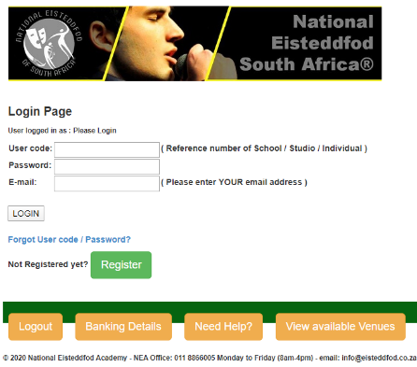
You will now have the option to LOGIN or REGISTER ONLINE if you have not registered yet.

When registering online for the first time, you are creating a new Billing Profile. All the entries that you submit online will be linked to this account with a unique Registration number.

To get started for the first time, click on the REGISTER button. This will take you to Part 1 of the Registration Process.

PART 1 of the Registration Process provides the following options:

- Individuals / Parents
- Schools (public & independent)
- Studios
- Community Organizations
- Tertiary Institutions

Select the options corresponds with your response to one of the following questions:

- Are you an individual parent or student with the intention to enter yourself or your child?
If the answer is yes, select the Individual Registration option.
- Are you a teacher / representative from a school, studio or community group that will enter a number of participants on behalf of your school or studio?
If the answer is yes, select the applicable option from the following: Private Studio, Public or Independent School, Tertiary Institution or Community Organization.

PLEASE NOTE: ONLY authorized representatives of schools / studios may register an Online Profile for a school / institution.
Parents or individuals entering on their own should select the “Individual registration” option.

The name of a school / studio / institution as used in Part 5 of the Registration Form should be the full OFFICIAL name of the institution (not an abbreviated version!)

The Online Profile is utilized for different purposes:

The Online Profiles for SCHOOLS are used as:
- BILLING PROFILE: This enables the office to allocate payments to the correct account when students enter and pay under the name of an institution.
- INSTITUTIONAL PROFILE: is used to link participants to the correct school in order to ACKNOWLEDGE the institution by printing the name of the school on individual certificates, as well as at the Young Performer Showcase events.

The Online Profiles for STUDIOS are used as:
- BILLING PROFILE: This enables the office to allocate payments to the correct account when students enter and pay under the name of a studio.
- TRAINER PROFILE: is used to ACKNOWLEDGE studios / trainers by linking the ENTRIES of participants to the studio that provides the training. This information will be printed on individual certificates, as well documentation at the Young Performer Showcase events.
- Please note: A Studio is NOT a school. The name of a studio should not be used as the name of a SCHOOL on any individual profile.

The Online Profiles for INDIVIDUALS are used as:
- BILLING PROFILE ONLY: This enables the office to allocate payments to the correct account when students enter and pay under the name of a parent.
- Parents / participants should make sure that they link the name of their school (not a studio!) to the online profiles of individual participants in order to have the name of their schools printed on their certificates and other documentation. More about this is provided in the ADD PARTICIPANT / ADD ENTRY help files on the website!
- Parents / participants should also make sure that they link the name of the studio or trainer to the ENTRY when they submit their entries. More about this is provided in the ADD PARTICIPANT / ADD ENTRY help files on the website!

Parts 2 to 4 of the registration form is straight forward and provides for information about your physical location.

PART 2 : Provides for the selection of a province:

PART 3 : Provides for the selection of a region within the province:
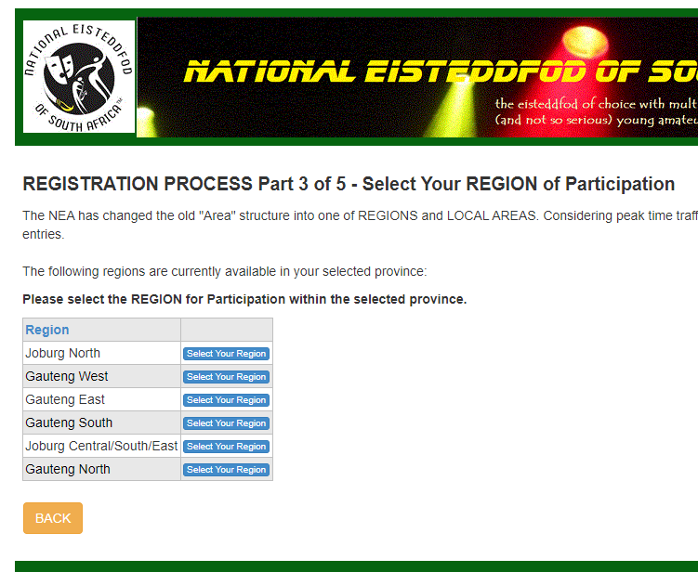
For practical reasons, due to the number of entries, Gauteng province has been divided into different regions.

Joburg North refers to the so-called northern suburbs, while Joburg City and the areas south and east of the City have currently been combined in to the Joburg Central/South/East region. Gauteng North refers to the Tshwane region, including Mamelodi and Soshanguve.

PART 4 : Provides for the selection of a local area within the selected region:
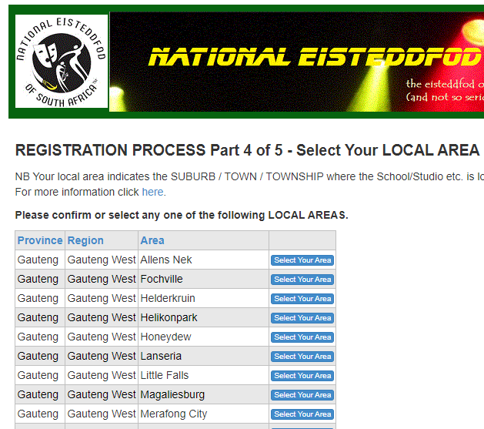
Available venues are contained within a local area. Subject to the availability of venues within a local area, the selected local area will determine the VENUES where you will be participating.

Carefully read through the list of local areas and select the local area that would be the most convenient. Please note that due to the special requirements of classical and contemporary music, as well as dance items, it is not always possible to host these items in all local areas. For this reason some local areas can be grouped together at an available and suitable venue in a nearby area. Please note that due to the cost of these venues a higher venue fee will be charged in some instances

PART 5 : This section of the ONLINE Registration form is of great importance and provides for the contact details for the school / studio / individual:

As indicated earlier, the OFFICIAL name of an institution should be provided. (E.g. Hoërskool Randburg and NOT Randburg Hoërskool). No “nick names” should be used. Individuals should provide the information in the order SURNAME, Name.
It is of critical importance to check your spelling when completing the form as names will be printed on certificates as was provided on the online system!

After completing this section, click on the SAVE button. Your user-code and password will now be displayed on the screen. (Make a note of this info and also mail this it to yourself for future reference).

If it so happens that the name you were attempting to register is already on the database, the following message will be displayed:
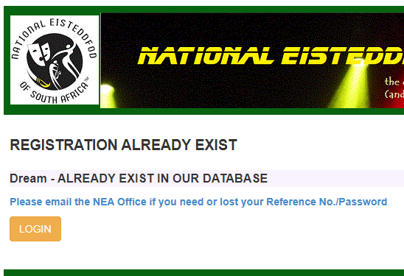
When you receive the message “Registration already exists”, it is possible that the name of your school was added by someone else in the past or that a section of the name as provided also appears in a name already registered. The purpose is to limit the registration of duplicates for the same organization.

You then need to contact the NEA office at register@eisteddfod.co.za for more information.

If the name as displayed is an individual other than yourself, you need to differentiate your name by including e.g. your full initials or date of birth as part of your name in order to create a new unique name.

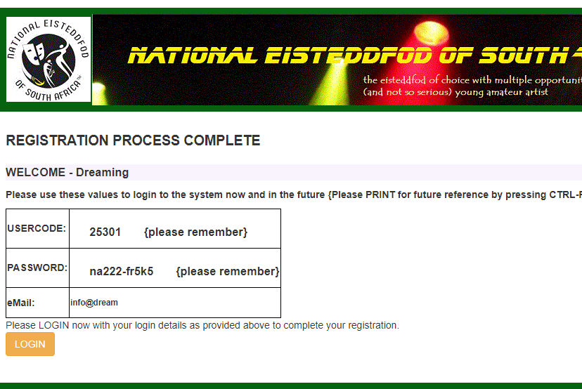

- Once you have received this LOGIN details (user-code and password), you will now be able to LOGIN.
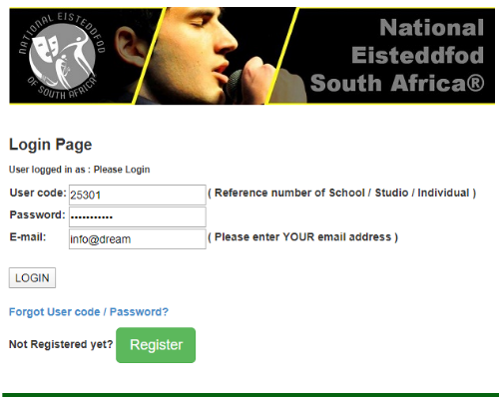
Click on the LOGIN BUTTON.

  - A new form will be displayed, asking for your User code, Password and E-mail.
  - Add the User-code and password that you have received, as well as your e-mail address.
  - Click on Login

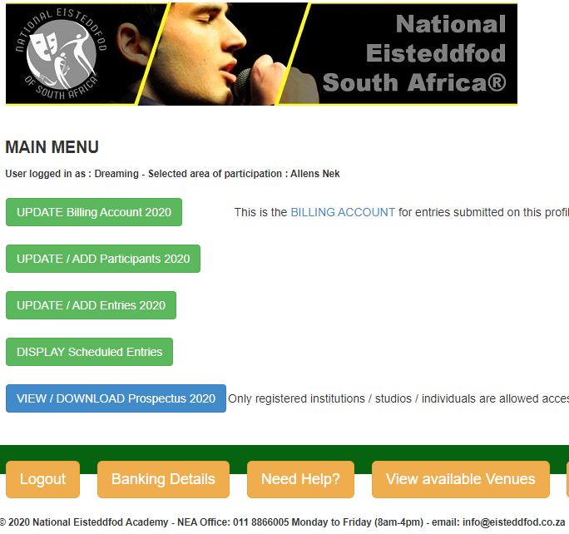
The MAIN menu that contains all the important buttons, will now be displayed.
If you are registering for the first time it is important to update the Billing Account.
Click on the first button on top of the page: UPDATE Billing Account
Update the incorrect or incomplete information by selecting the appropriate option from the dropdown lists (some questions are more applicable for use by a school).
IMPORTANT: Click on SAVE ENTRY before you click on BACK!
Once you have completed your ONLINE registration, you are on our active mailing list and should receive all our communication via our email platforms.
Depending on the setting of individual mail boxes, it is always possible that an e-mail can end up in the junk mail or trash box. Therefore we use various methods of communication, including social media. It is recommended that you also like our Facebook page as we often do important announcements on this page. The Facebook address is as followings: www.facebook.com/nearsa
Finally: All registered institutions and individuals have access to the online version of the National Eisteddfod of South Africa® Prospectus. For full information, item numbers, requirements and guidelines of the various disciplines, click on the blue VIEW DOWNLOAD Prospectus 2020 button. You can then download and print any of the available sections. You can also order a printed copy of the Prospectus from the NEA Office if you wish to do so.
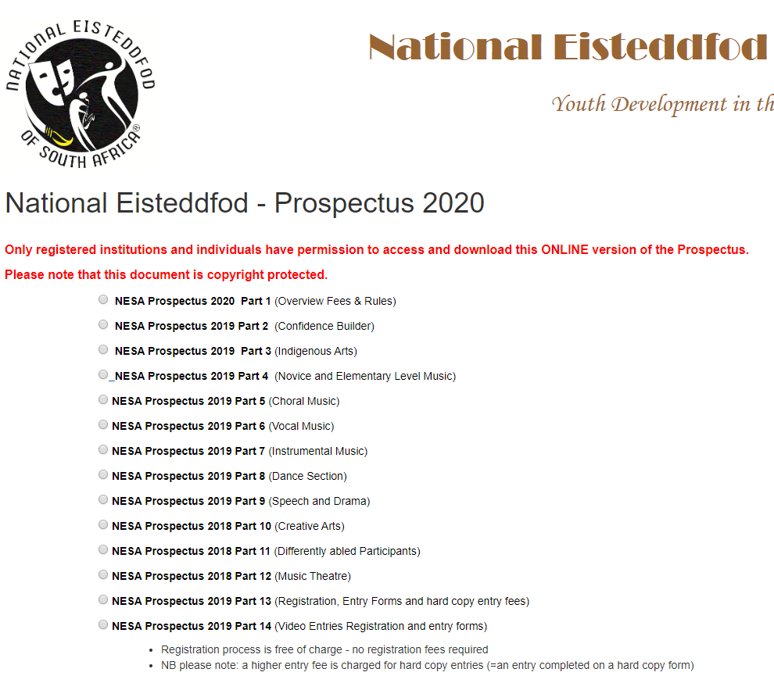

This desire is one of the basic needs as described by Abraham Maslow in his 1943 paper “A Theory of Human Motivation”. Since then this theory has been generally accepted by behavioural psychologists to describe the way in which human beings behave. 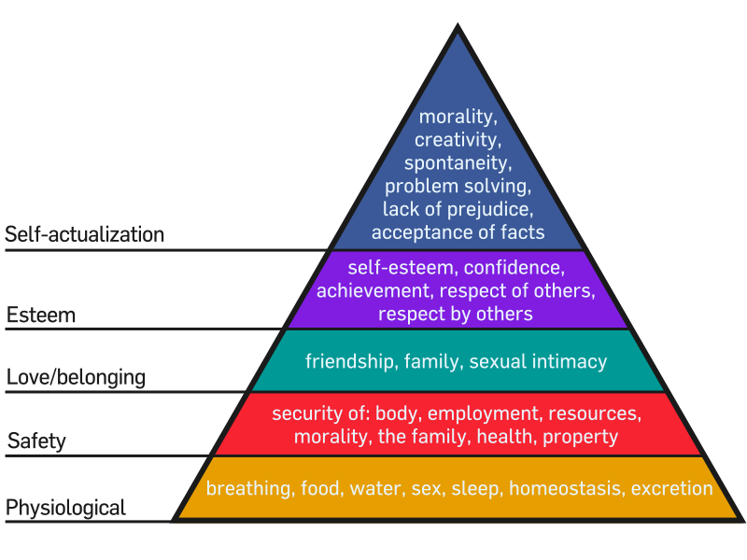
A traditional Welsh festival at which competitions are held for performers and composers of music and poetry (Encarta).
Subject to change.
Any changes to or extension of deadlines will be announced on the website and Facebook page.
Yardsticks in this context refer to all the elements of the relevant discipline that contribute towards a successful performance. Also refer to the example of a rubric tool on page 32.
E.g. when a participant obtained 2 diplomas in Narrative Poetry, Gr. 5, only the event with the highest mark (e.g. 93% compared to 90%) will be considered. Based on this formula a participant with e.g. 3 diplomas in Unprepared Reading Grade 4 will receive 30 marks towards his total, compared to 3 x 30 in the past.
Courtesy of Adrian Freeman, Pro Alphen Park School

