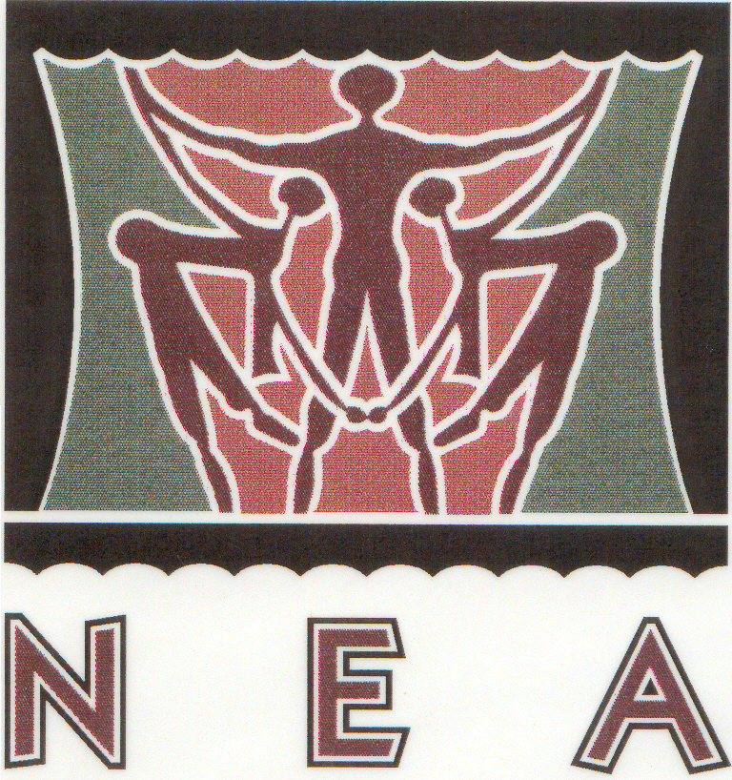
NATIONAL EISTEDDFOD YOUNG ARTIST AWARD 2025
ENTRY FORM FOR ART ACHIEVEMENT IN OTHER FESTIVALS
Important: ALL sections MUST be completed

First Name:
Surname:
Date of birth: |  | School Grade in 2025:
Name of school in 2025
Name of parent/responsible person
Contact details of parent / person responsible for this entry. | Home tel. no: | Fax no:
 | Cell. no: | Work no:
 | E-mail address:
Please print clearly! All sections must be completed. Incomplete entries cannot be processed.

NEA AWARDS: Categories and codes:

Awards Cat No | Awards Category Description | Awards Grades
NEA-044 | Creative Arts | Entry Level (Gr. 0 - 3)
NEA-045 | Creative Arts | Junior (Gr. 4 - 7)
NEA-046 | Creative Arts | Senior (Gr. 8 - Open)

- Please complete a separate entry form for EACH art work that you are submitting.
- Select the NEA Awards category number from the list above. (The Grade refers to the school grade in 2024 when the art work was created.)
- NB: Provide both the NEA Awards number (see above) and the description of the item that you did in 2024 at the other festival.

NEA AWARDS CODE for 2025 |  |  |  | DESCRIPTION OF ITEM / CATEGORY AS ENTERED FOR ANOTHER FESTIVAL IN 2024 (Painting, drawing, sculpture, collage, etc.) | ENTRY FEE
NEA
AMOUNT PAYABLE : |  |  |  |  | R
Theme / Title of Art Work:
Rules
- Please attach a copy of the diploma of similar certificate as awarded at another festival in 2024 to your entry.
- A panel of adjudicators will adjudicate all entries and their decision is final.
- Submit this HARD COPY entry form WITH the entry fees BEFORE the closing date for entries by e-mail to entry@eisteddfod.co.za.
- NB Please attach a copy of the completed entry form to each art work before submitting it to the NEA Office. Submitance of the artwork attached to this entry form constitutes a declaration that it is the participant’s own creation.
- The theme used for this art work and the “name” of the piece should be provided in the box on the entry form above.
- All art works must be submitted to the NEA office not later than 25 April 2025.
- Address for collection and delivery: National Eisteddfod Academy, Bergzicht Office Park, Block 3, Suite 15, Cnr. Christiaan de Wet & Rooibok Str., Allen’s Nek, 1709.
- Art work can also be submitted via PostNet to PostNet Strubensvale.
- Participants will receive notifications once the adjudication has been completed and when artworks can be collected.

ENTRY FEES | CLOSING DATE | ENTRY FEE PER ENTRY
Early Bird Hard Copy Entry Fee | 01 March 2025* | R 350
Hardcopy Entry fee | 28 March 2025* | R 380
Late Entry fee (hard copy only) | 25 April 2025* | R 400
*Entry fee / proof of payment should accompany the entry form.

Please indicate with √ in the appropriate box. |  |  | ELECTRONIC TRANSFER / DIRECT BANK DEPOSIT to National Eisteddfod Academy ABSA current account:
 |  |  | Account number: 404 747 8448 | Branch code: 632-005 | Type: Current account
 |  |  | Date of transfer / transaction: |  | NB Please provide the name of participant as reference.
Cheque | EFT | CASH | It is of vital importance to provide the participant’s name as reference when making electronic payments. Kindly email proof of transfer to entry@eisteddfod.co.za or attach this proof when submitting the entry.  IMPORTANT: NO entry will be processed without proof of payment.
I accept the rules of the National Eisteddfod Young Artist Award Competition.

___________________________ Date:__________
Official use only: | Received | Outstanding | Entry Captured and Checked by
Proof of payment
Date:

